

FOR IMMEDIATE RELEASE Contact: Lance Sumler
lsumler@xula.edu

Xavier University of Louisiana names Ashley Irvin as
Director of Marketing and Communications

Xavier University of Louisiana has appointed Ashley Irvin as Director of Marketing and Communications. Irvin joined the institution in March of 2018 and was quickly recognized as a rising leader in the department serving in progressively responsible management roles.
With this permanent appointment, she will continue and expand the work she began upon her appointment in an acting capacity in April of 2020. Irvin will continue to partner with colleagues on various institutional initiatives and projects. Her management portfolio includes internal and external communications, digital; presence across all channels, crisis communication response, and communication innovation. Her contributions and leadership have continued to streamline and integrate communication efforts.

“Ashley’s leadership will be instrumental in the continued growth and visibility of our university,” said Patrice A. Bell, VP and Chief of Staff at Xavier University of Louisiana. “Xavier’s mission is to empower students through education so that they can go on to become ethical leaders and change agents that impact our city, and our world. Ms. Irvin’s experience and communications skills will increase the University’s visibility as we work to create a more just and humane society.”
Irvin served as the External Affairs Manager for Xavier University Office of the President and as Xavier's Marketing Communications Specialist, leading the marketing efforts for the BUILD program.
Prior to joining Xavier, Ms. Irvin served as the Communications Assistant and Liaison for the City of New Orleans in the Landrieu administration where she oversaw the execution of citywide communications programs, special events and public meetings, in addition to social media management, internal and external correspondences, media inquiries and strategic marketing campaigns. She also worked as a field organizer on the campaign of Senator Mary Landrieu and Deputy Clerk for the Orleans Parish Civil District Court, where she gained experience planning community-based events and political campaigns.
As Director of the Marketing Communications office, Irvin will lead marketing efforts for develop marketing strategies for the University as well as manage media outreach, advertising campaigns, social media, and branding implementation for the organization.
Ashley Irvin has a Bachelor’s degree in Mass Communication from Loyola University, New Orleans and an MBA from the University of New Orleans.

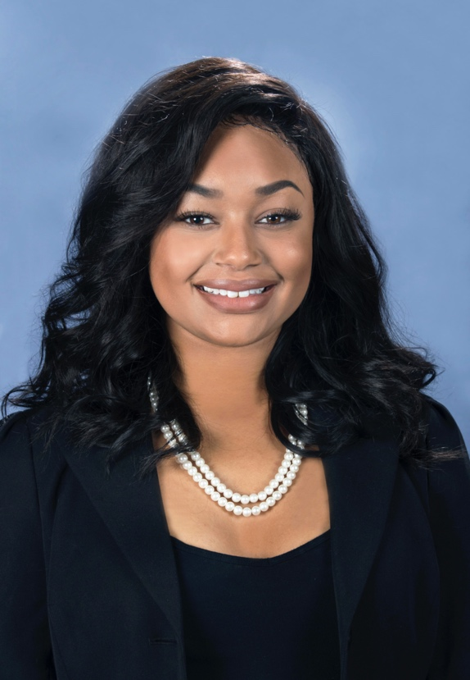

Ashley Irvin
Director of Marketing and Communications
Xavier University of Louisiana

# # #

About Xavier University of Louisiana
Being America’s only historically Black and Catholic University is only the first among many distinctions that have set Xavier University of Louisiana apart for more than nine decades. Despite its relatively small size (3,300 students), Xavier is a nationally recognized leader in the STEM and the health sciences, producing more African American students who graduate from medical schools each year than any other university in the United States. Its College of Pharmacy is among the top producers of African American pharmacists.
Its liberal arts-based programs in such areas as art, business, education, psychology, and political science – as well as recent additions in bioinformatics, data science, neuroscience, crime and social justice, and jazz studies – offer students an unbeatable combination of traditional classroom study, hands-on research, service-learning opportunities, and life experiences. The winning Xavier formula to provide students with a well-balanced curriculum and an environment that nurtures their intellect and feeds their souls.
For more information about Xavier University of Louisiana, visit us online at www.xula.edu or follow us on Facebook, YouTube, or Twitter @XULA1925. To book interviews and/or to speak with our experts in the field of pharmacy, education, premed, public health, science, technology, math, business, English, communications, and the arts, contact Lance Sumler at (504) 520-5240 or lsumler@xula.edu.

