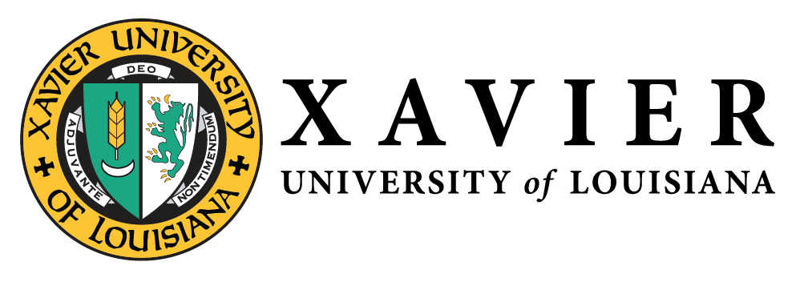
National Alumni Association
1 Drexel Drive, Box 66 • New Orleans, Louisiana 70125 • (504) 520-7575 • FAX (504) 520-7915

NATIONAL ALUMNI  OFFICERS 2019-2021  1 Drexel Drive  Campus Box 66  New Orleans, LA 70125  (504) 520-6782  1-877-WE LUV XU  Mr. Randall McHenry ’86  President  randall@mchenryinc.net  Dr. Trevonne Thompson ’97  1st Vice President  Trevonne.thompson@gmail.com  Ms. Chakita Holmes ’03  2nd Vice President  chakitaholmes@gmail.com  Mrs. Nicole M. Golden ’00  Corresponding Secretary  ndmarchand@gmail.com  Ms. Tiffany Devereaux ’98  Recording Secretary  ttdex@yahoo.com  Mr. Kevin Barnes, Jr. ’10  Treasurer  kevinlbarnesjr@gmail.com | Xavier University of Louisiana  National Alumni Association Centennial Endowment Fund Committee  April 4, 2020  Attendees: Elease Bradford, James Paschal, Rosalind Hale, Teal Holden, Keith Blossom  The NAA Centennial Endowment Fund met on Saturday, April 4, 2020 to discuss the endowment fund campaign progress and next steps. Keith Blossom gave a status update of donations given. At that time, a total of 16 alumni with 1 matching company gift had been pledged. In addition, mailed letters were sent to previous XULA donors that have not given in the last 3-5 years on March 5th.  The committee discussed several next steps to be discussed at the next board of governor’s meeting. Those include the following:  - Committee Outreach  - Expand Committee - New committee members to include 1-2 members from each chapter  - Develop Schedule for Phone Tree/Calls  - Create Google shared document for tracking purposes  - Update Website/Landing Page  - Add Endowment Fund on the main Alumni Page (move from Alumni Chapters link)  - Visual of goal to be added to Website  - Create an Endowment Fund Toolkit to include:  - FAQ  - Talking Points  - Pledge Calculator  - Sample Endowment Fund Flyer  - "I Pledged Because" Video scripting  - Endowment Fund Letter  - Pledge Card  - Endowment Fund Thank You Letter  - Designate September/October as campaign months for local area chapters to host events to garner donors for the Endowment Fund.  - Challenge all NAA Officers, Chapter/Affinity Group Leaders, and Alumni Chapter/Affinity Groups to make their pledge at Homecoming 2020.  - Homecoming 2020  - “Become a Centennial Donor” Pop-Up Booth  This report is submitted for informational purposes only.

