**Student ePAF User Guide**



**Office of Human Resources**

**Table of Contents**

|  |  |
| --- | --- |
| **Topic** | **Page Number** |
| **Introduction to ePAF** | **3** |
| **Terminology** |  |
| ePAF Roles | **4** |
| ePAF Statuses | **4-6** |
| **Requirements** |  |
| Prerequisites for Originating an ePAF | **7** |
| **Standard Procedures** |  |
| Originating a Transaction for Approval | **8** |
| I. Accessing Banner Client Form NOAEPAF | **9** |
| II. Entering Key Block Data | **10** |
| III. Entering New Values for Job Details | **11-17** |
| IV. Entering New Values for Job Labor Distribution | **18-19** |
| V. Entering New Values for End Job Details | **20-23** |
| VI. Entering Additional Information for Job Details | **24** |
| VII. Submitting the Transaction for Approvals | **25** |
| **Errors and Warnings** |  |
| Identifying and Correcting ePAF Errors and Warnings | **26** |
| Common Errors and Warnings | **27-28** |
| **Approving an ePAF** |  |
| Option 1- Approve Transactions on the NOAEPAF Form | **29** |
| Option 2- Approve Transaction on NOAAPSM Form | **29-31** |
| **ePAF Frequently Asked Questions (FAQs)** | **32-35** |

**Contact:**

**HR Student ePAF Administrator  
ext. 5738**

**Introduction to Electronic Personnel Action Form (ePAF)**

**What is ePAF?**

ePAF is a more efficient way to accommodate the approval signature process for centralized and decentralized HR operations. It will allow users to track their items requiring approval through a form in Banner Client and allows “Approvers” to easily view actions that need approval signatures and add their own comments to an action.

To complete an action for an employee, an *Originator* accesses the Banner Form NOAEPAF, enters the requested data and then submits the document to be routed for approval. Once the document is approved by all of the required Approvers, Human Resources applies the action to the database and an employee’s job information is either created or updated in Banner.

**Terminology**

**Enter Query Date**

**ePAF Roles**

**Originators**

The creator of an Electronic Personnel Action (ePAF). The Originator will be the first person who commits data entered on the Electronic Personnel Action Form (NOAEPAF) to the database (i.e., Administrative Assistant, Administrative Specialist, PI, Supervisor, etc.).

**Approvers**

Individuals who are responsible for approval/disapproval, acknowledgment, one who can return ePAFs to the Originators for corrections, or one who can apply ePAFs to the database. Once established in this role, one should incorporate the task of approving ePAFs into his/her daily tasks.  
  
**Proxy**Any Originator or Approver can establish a proxy whose role would be identical to theirs in their absences. This individual can be set upby providing HR with the new users name and XUID at any time prior to the absence and will remain unless a request is made to assign a new proxy. A proxy must be established as a Banner Client user in advance of the need.

**ePAF Statuses**

An ePAF is associated with two display-only status fields throughout the procedure, the **Transaction Status** field and the **Queue Status** field.

**Transaction Status:**Refers to the status of the Electronic Personnel Action (ePAF) itself. The **Transaction Status** field appears in the Key block of the form. This field indicates the status of the transaction throughout the approval process. Initially, the **Transaction Status** field is blank. The status changes to *Waiting* as soon as the Originator saves the data he/she has entered for the first (or only) approval types for the current approval category. The status changes to *Pending* when the Originator submits the transaction for approval. The status changes to *Approved* when all Approvers whose required action is *Approval* have approved the transaction. Finally, when the transaction is applied to the database by HR, the transaction status becomes *Complete*.

**Status Description**

|  |  |
| --- | --- |
| **Waiting** | The transaction is in the process of being created and has not been submitted to the approval queue. When an electronic approvals transaction is in *Waiting* status the transaction can be deleted by selecting the **Delete PAF** from the Options menu of the Electronic Personnel Action Form (NOAEPAF). |
| **Pending** | Indicates that the transaction requires positive action by the Approver(s). The transaction remains at this status until action is taken by the person required to take action on the transaction. |
| **Return for Correction** | This status will allow you to return the transaction to the Originator for correction when an error is detected prior to final approval or application to the database. The ePAF can be updated and then resubmitted to the approval queue. If the transaction is resubmitted to the approval queue, all individuals defined in the approval queue will be required to take action on the transaction again. |
| **Approved** | The transaction status is approved for the person when all the person(s) defined in the approval queue has approved the transaction. |
| **Complete** | The transaction status becomes *Complete* after the transaction has been applied to the database. |
| **Partially Completed** | The apply person has indicated that the remaining portion of the transaction will be applied at a later date. This status is typically in use when a transaction contains employee data for Employee Record (PEAEMPL) and job information (NBAJOBS), where a future job change would necessitate a future Employee Record change. |
| **Disapproved** | The transaction has been disapproved by a person defined in the approval queue. The individuals defined after them in the approval queue can no longer need to take action on the item. |
| **Void** | The Originator or Superuser has voided the transaction. It is no longer a valid transaction. |
| **Canceled** | This status will be used when you opt to cancel an entire transaction after it has been applied to the database. |

**Queue Statuses:** The **Queue Status** field indicates the current status of the transaction for each Approver throughout the approval process. For example, the queue status, *In the Queue*, indicates that the transaction is on its way to an Approver but needs approval action at a lower level, the *Pending* status indicates that the Approver needs to take positive action on the transaction, the *Approved* status indicates that the Approver has approved the transaction, and the *Applied* status indicates that the Approver has applied the transaction to the database.

**Status Description**

|  |  |
| --- | --- |
| **Pending** | Indicates the Approver(s) needs to take positive action on the item. |
| **Approved** | Indicates that the Approver has approved the transaction. |
| **Disapproved** | Indicates that the Approver has disapproved the transaction. |
| **Void** | Indicates that the transaction has been voided. Valid queue status for the Originator and *Superuser* only. |
| **FYI** | Indicates that the transaction is for information only. This queue status indicates that the transaction has been sent to you for your information only. No positive action is required. |
| **More Information** | Individuals defined in the approval queue with a required action of *Approval* may need more information about the transaction prior to taking positive action. If this is the case, the Approver can change the status to more information. This identifies to the other individuals in the approval queue that some action is being taken. |
| **In The Queue** | The transaction is on the way to you as the Approver but needs action at a lower level. Transactions must be approved in the sequence defined in the Routing Information on the ePAF. Therefore, until the action has been approved by the person defined before you in the routing of the ePAF the status of *In the Queue* will appear on your transactions. While the status is *In* *the Queue*, the individual cannot take action on the transaction. The status changes to *Pending* when the transaction reaches you in the approval queue process. |
| **Acknowledge** | Action taken by a person in the approval queue for whom the transaction was sent to with a required action indicator of FYI. Indicates that the FYI person has seen the transaction. |
| **Overridden** | This queue status is system generated. The status indicates that the approval for users who have not taken action was overridden by the Superuser at the time the Superuser approved the transaction. |
| **Removed from Queue** | This queue status is system generated. This status indicates that the Originator or Superuser has voided the transaction and it is no longer in the queue. |
| **Return For Correction** | Indicates that the ePAF has been returned to the Originator of the transaction for correction. |
| **Applied** | Indicates that the transaction has been applied to the database. This queue status will be valid when a transaction has been applied to the database and the transaction status is complete or partially complete. |

**Requirements**

**Prerequisites for Originating an ePAF**

Prior to creating an ePAF, the following must happen to ensure that an ePAF can be submitted without interruption:

1. An Originator/Creator of an ePAF must have a Banner Client username and password and must have access to form NOAEPAF before he/she can create an ePAF. If you do not possess these credentials, please notify HR and a username, password, and form access will be requested as necessary.
2. An ePAF Supervisor must be consistently employed with the University and have a valid job record (ePAF) in the Banner Client system to be listed as the Supervisor on a student ePAF and act as a student Supervisor.
3. The hiring department is required to have the employee to report to Human Resources to complete new hire paper work for employment eligibility before the ePAF is originated and before employee can begin working if the employee has not worked in the capacity of student employee within the last twelve (12) months.
4. The hiring department must verify that the student does not already have a Federal Work Study job assigned by the Office of Financial Aid. Combining Departmental Hire Program positions with Federal Work Study is prohibited.
5. The following information will also need to be available:

|  |  |
| --- | --- |
| **Data Fields** | **Description** |
| **Hire/Rehire’s XULA ID** | Xavier University Identification Number for the employee being hired/rehired |
| **\*\*Position Number** | Identifies the position assignment that the employee is to fill based on position funding. This must be obtained by contacting the Compensation Analyst in HR. Position numbers are uniquely tied to the funding and will not change unless the fund code changes. |
| **Effective Start Date of the Position** | A future date the employee is expected to start working in the position  **Warning:** Retroactive dates are prohibited. A two-week lead time on the start date of a position is required to begin originating an ePAF. (i.e., today is August 1st, the student’s start date cannot be prior to August 15th) |
| **Effective End Date of the Position** | The last date that the employee is allowed to work in the position  **Note:** This date should be considered using the academic and biweekly pay period calendars |
| **Labor Distribution** | Includes fund code from which the employee’s wages are to be paid from along with the organization code, account code, program code, in some cases activity code, and percentage of time (must equal 100%) |
| **Salary** | Amount of money that the employee is expected to be compensated for work in the position per semester |
| **Supervisor’s XULA ID** | Xavier University Identification Number of the Student Employee’s Supervisor |

**Standard Procedures**

**Originating a Transaction for Approval**

Detailed below are the steps that a user should follow to Hire/Re-Hire a student employee using ePAF.

**I. Accessing Banner Client Form NOAEPAF**

****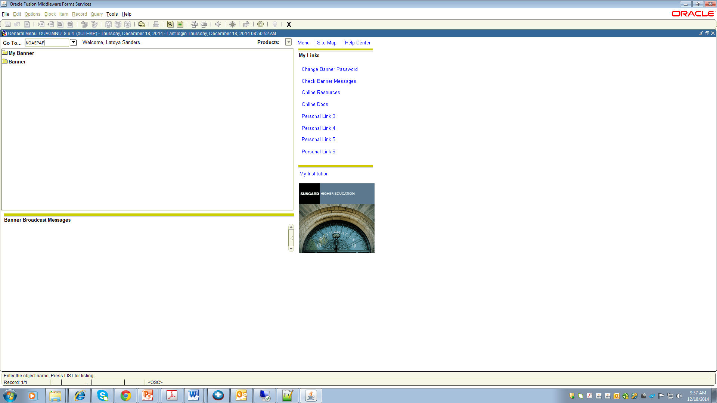

**2.**

|  |  |
| --- | --- |
| **Step 1.** Access **Banner Client** | 1. Access the **XULA Home Page** 2. Select **“Banner Client”** from the top left-hand corner of the homepage. |
| **Step 2.** Access the Electronic Personnel Action Form in Banner Client **NOAEPAF** | Enter Banner Client form name **NOAEPAF** in the field to the right of “Go to…” |

**II. Entering Key Block Data**

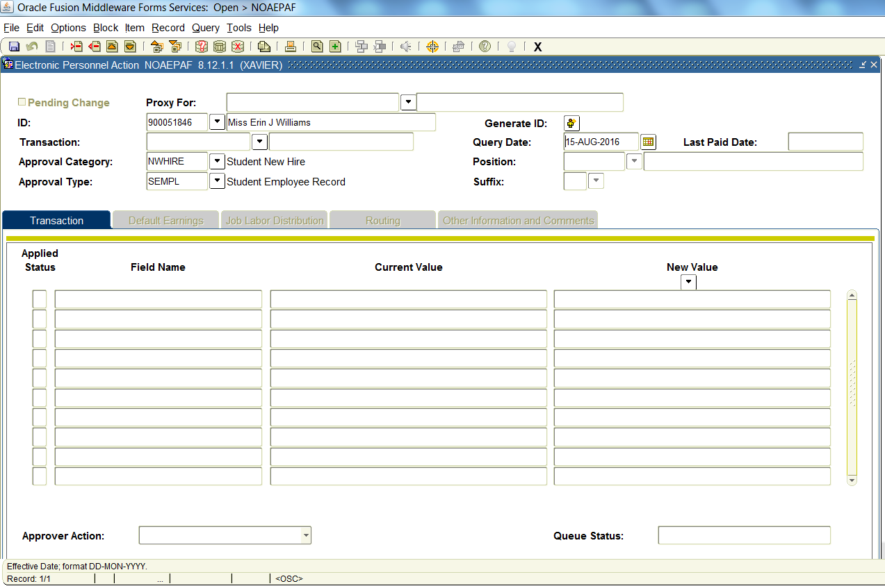

Key Block

Icons

Toolbar

**6.**.

**4.**.

**3.**.

**5.**.

|  |  |
| --- | --- |
| **Step 3.** Enter the **XULA ID** | Enter the **ID** of the person (the employee) for whom the Electronic Approval transaction is being created. |
| **Step 4.** Enter **QUERY DATE** | Enter the **Query Date**. The query date must be a future start date for the position being created. (i.e., today is Aug 1, the earliest query date would be Aug 15).  **Note: There should be a two week lead time prior to the start date on the position when originating an ePAF.** |
| **Step 5.** Entering the **Approval Category**  NWHIRE (Approval Types Associated: *SEMPL, START, END*)  REHIRE (Approval Types Associated: *START, END*) | Enter **“NWHIRE”** in the Approval Category Field. (Student who has never had a position in the Unit that is paid from the funding that this position will pay from)  In the ‘Approval Types’ field, the first type in sequence will auto populate, ‘**SEMPL’**  **OR**  Enter **“REHIRE”** in the Approval Category Field. (Student who has had the same position in the Unit, that is paid from the same fund)  In the ‘Approval Types’ field, the first type in sequence will auto populate, ‘**START’** |
| **Step 6.** | Click **“Next Block”** from the Toolbar or Icons to enter the Transaction Tab |

**III. Entering New Values for Job Details**

**8.**

**7.**

**7.**

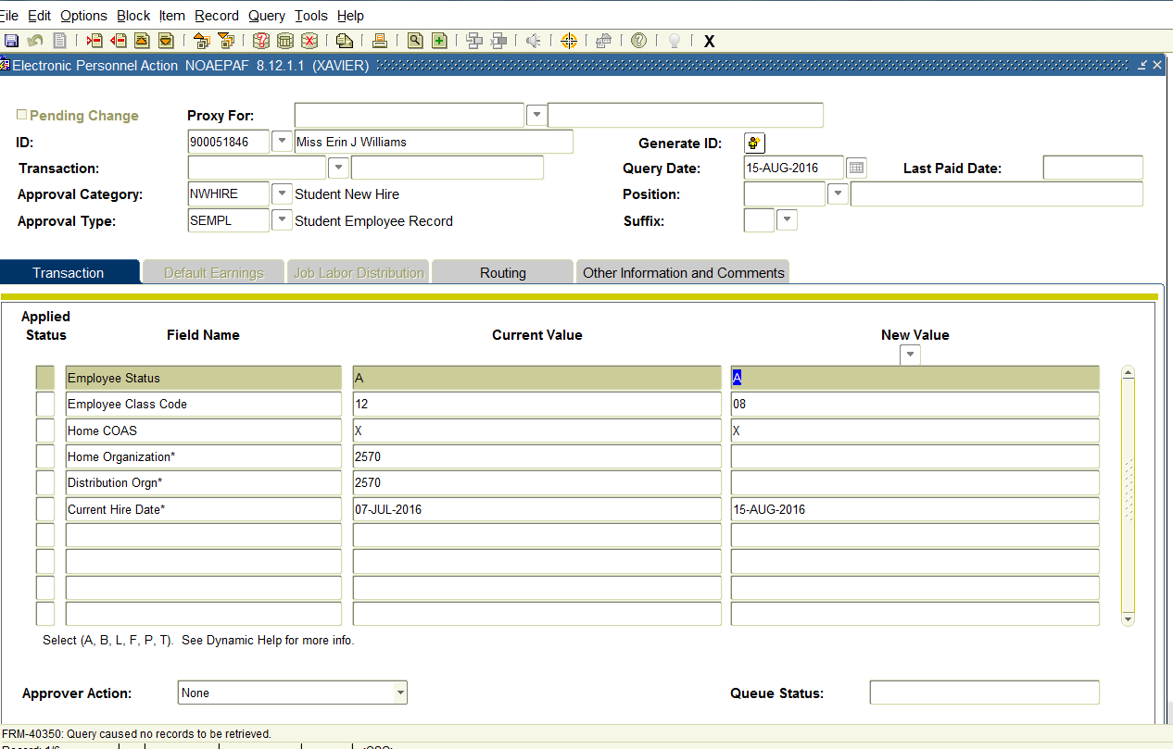

**4-digit org code**

**4-digit org code**

|  |  |  |  |  |  |  |  |  |  |  |  |  |  |  |  |
| --- | --- | --- | --- | --- | --- | --- | --- | --- | --- | --- | --- | --- | --- | --- | --- |
| **Step 7.** Entering New Values for **Approval Type SEMPL** *(First in Sequence for NWHIRE)* | |  |  | | --- | --- | | **Field Name** | **Description** | | **Employee Status** | Default **“A”** | | **Employee Class** | Default **“08”** | | **Home COAS** | Default **“X”** | | **Home Organization** | Enter 4-digit **Organization Code** that employee will work in (i.e., Chemistry 1233) | | **Distribution Organization** | Enter 4-digit **Organization Code** that employee will work in (same as home organization) | | **Current Hire Date** | Defaults same as query date entered in Key Block | |
| **Step 8.** **Save** the Data Entered | Click **“Save”** from the Icons to commit the data entered.  **Note:** A transaction number is assigned to the action at this point once the ePAF is in Waiting status. You should record the transaction number so that you can track the status of actions. There are no allowances to change a query date upon saving. If an error occurs with the query date, delete the ePAF at this stage and start anew.  **Note:** To delete an ePAF, choose Options from the Toolbar and select “Delete PAF” to remove an ePAF that has not yet been submitted for transaction. |

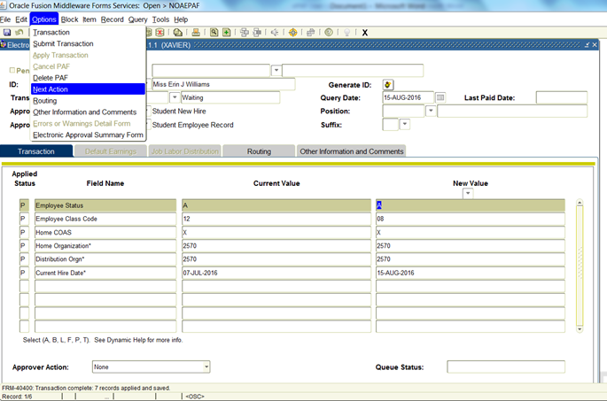

**9.**

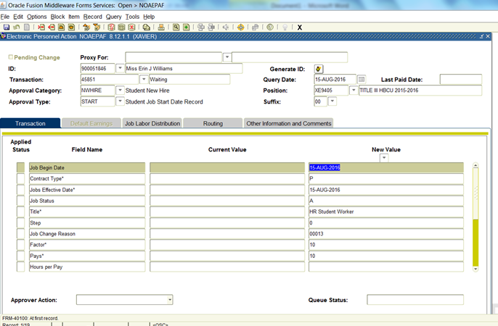

**10.**

|  |  |
| --- | --- |
| **Step 9.** Selecting **Next Action** to Enter New Values for **Approval Type START**  *(Second in sequence for NWHIRE, first in sequence for REHIRE)* | Click **“Options”** from the Toolbar and select **“Next Action”** to navigate to the next Approval Type in sequence, **“START”**. This displays additional fields in the “Transaction Tab”. |
| **Step 10.** Entering the Employee’s **Position Number and Suffix** | Enter the employee’s **“Position Number”** in the position field andenter **“00”** in the suffix field  **Warning:** Position numbers are provided to users by HR. They are uniquely tied to funding. Funding cannot be changed on a position number. If there is a need to use a fund other than the one associated with the position number provided, please contact HR for a new position number. |
| **Step 11.** | Click **“Next Block”** from the Toolbar or Icons to enter the Transaction Tab |



**13.**

**12.**

**Scroll Down for More Fields**

**(12) Enter required data in this column**

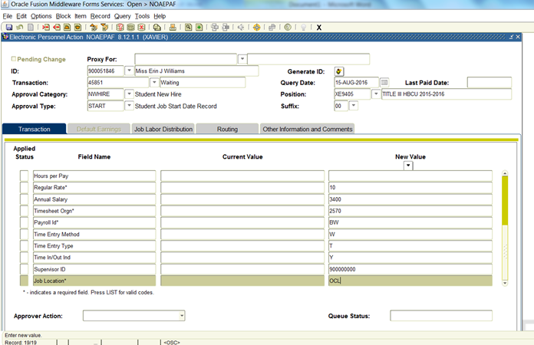

**14.**

**12.**

|  |  |  |  |  |  |  |  |  |  |  |  |  |  |  |  |  |  |  |  |  |  |  |  |  |  |  |  |  |  |  |  |  |  |  |  |  |  |  |  |  |  |
| --- | --- | --- | --- | --- | --- | --- | --- | --- | --- | --- | --- | --- | --- | --- | --- | --- | --- | --- | --- | --- | --- | --- | --- | --- | --- | --- | --- | --- | --- | --- | --- | --- | --- | --- | --- | --- | --- | --- | --- | --- | --- |
| **Step 12.** Entering the Employee’s **Job Detail Information** to Start the Job  *(Use the scroll bar on the right to scroll down for more fields.)* | Enter the data listed below in the **“New Value”** column based on the data requested in the **“Field Name”** column.   |  |  | | --- | --- | | **Field Name** | **New Value** | | **Job Begin Date (Tip:** This is the first date the employee ever had this same position in your Unit; therefore the “job begin” date will never change and should be entered as such. This field can be left blank only when using REHIRE. When using NWHIRE a job begin date is required.**)** | Future date employee will begin working, if NWHIRE is used (should match query, current hire, and job labor distribution effective dates)  **OR**  This date should be left blank, if REHIRE is used | | **Contract Type** | Default **“P”**  **Warning:** This field cannot be updated unless authorized by Human Resources. Changing this default without authorization will result in the ePAF being “Returned for Correction” | | **Jobs Effective Date** | Future date employee will begin working (should match query, current hire, and job labor distribution effective dates) | | **Title** | Job title must be specific to department name Student Worker  (i.e., HR Student Worker) | | **Job Status** | Default **“A”** | | **Step** | Default **“0”** | | **Job Change Reason** | Default **“00013”** | | **Factor** | The total number of pay periods the employee  will be paid  ***(Ex: Job begins August 22nd through Dec 14th –9 factors, 9 pays)***  **Note:** Students are paid on a biweekly basis. See biweekly pay period calendar for assistance. | | **Pays** | The total number of pay periods the employee  will be paid  (Pays should match the amount of Factors; i.e., 9 Factors = 9 Pays) | | **Regular Rate** | Enter the **Hourly Rate** for the employee  **Note:** Hourly rate range for student employees is $7.25/hr - $15/hr | | **Hours Per Pay** | Blank (Non-Editable field) | | **Annual Salary** | Enter the **Total Amount** the student should be paid during the employment period. Should be an amount determined per semester.  **Note:** Calculation is Hourly Rate x Hrs per Week x Total Number of Work Weeks = Salary Amount | | **Time Sheet Organization** | Enter **Organization Code** where the employee will need to access his/her timecard | | **Pay ID** | Default **“BW”** | | **Time Entry Method** | Default **“W”** | | **Time Entry Type** | Default **“T”** | | **Time In/Out Ind** | Default **“Y”** | | **Supervisor ID** | Enter the **XULA ID of the Supervisor** responsible for approving the employee’s electronic time sheet in Banner Web Time Entry  **Warning:** The supervisor must have a valid ePAF in the Banner Client system with an active job record in order to supervise student employees. Any breaks in employment record for the supervisor will result in his/her employees’ inability to clock in due to invalid supervisor error.  **Note:** A proxy can be set up for the supervisor in the event of his/her absence for approval by providing the proxy’s name and 900# to HR. This must be established prior to the supervisor’s absence. | | **Job Location** | If the employee will be working from a specific location on the main campus of the University enter **“OCL”-On Campus**  If the employee will be working from a specific location off the University campus only enter **“OFL”-Off-Campus**  **Warning:** All OFL locations must add the identified physical location under the “Other Information and Comments” tab in NOAEPAF; otherwise the ePAF will be Returned/Correction.  If the employee will be working from both an on and off campus location enter **“HYL”-Hybrid**  **Warning:** All HYL locations must add the expected physical locations under the “Other Information and Comments” tab in NOAEPAF; otherwise the ePAF will beReturned/Correction. | |
| **Step 13. Save** the Data Entered | Click the **“Save”** icon to save the data entered |
| **Step 14.** | Click the “**Job Labor Distribution**” Tab |

**IV. Entering New Values for Job Labor Distribution**

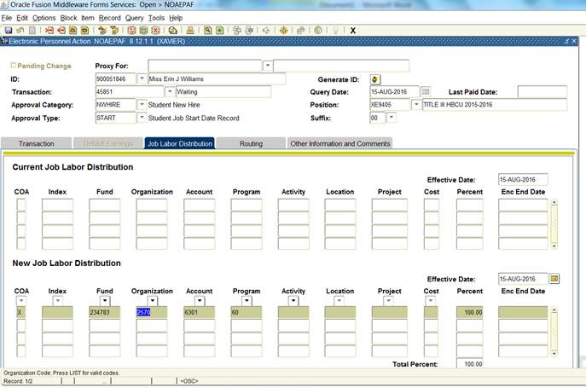

**16.**

**15.**

**15.**

|  |  |  |  |  |  |  |  |  |  |  |  |  |  |  |  |
| --- | --- | --- | --- | --- | --- | --- | --- | --- | --- | --- | --- | --- | --- | --- | --- |
| **Step 15.** Entering **Job** **Labor Distribution** Information  **Note:** HR will inspect each ePAF submitted to ensure that the position number entered is assigned to the fund on the Labor Distribution Tab. If they should find that the two do not match they will return the ePAF for you to void and you will have to create a new ePAF using the correct fund and position number. Position numbers are uniquely tied to fund codes and therefore fund codes cannot be changed.  **Note:** In order to void an ePAF, you must be on the “Transaction” tab. Click the drop down arrow next to the “Approver Action:” field at the bottom of the page and select “Void” to remove an invalid transaction and press “Save”. The ePAF transaction status will update to “Void” next the “Transaction” number field in the Key Block. | |  |  | | --- | --- | | **Labor Distribution Fields** | **Description** | | **Effective Date** | Future date employee will begin working (should match query, current hire, and jobs effective dates) | | **Fund** | Default “**Fund Code**” (6-digit code) | | **Organization** | Enter the **Organization Code** of the Unit that will benefit from the service (4-digit code) | | **Account Code** | Default **“6301”** | | **Program Code**  **Activity Code** | Enter the **Program Code** Associated with the fund (2-digit code)  Enter the **Activity Code** Associated with the fund (does not apply to all funds) | | **Percent** | Enter the percentage of the employee’s salary that should be charged to the fund (must equal 100%) | |
| **Step 16. Save** the Data Entered | Click the **“Save”** icon to commit the data entered |

**V. Entering New Values for End Job Details**

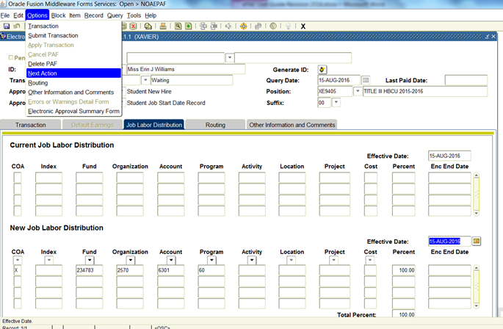

**17.**

|  |  |
| --- | --- |
| **Step 17.** Selecting **Next Action** to Enter New Values for **Approval Type END**  *(Third in sequence for NWHIRE, second in sequence for REHIRE)* | Click **“Options”** from the Toolbar and select **“Next Action”** to navigate to the next Approval Type in sequence, **“END”**. This displays additional fields in the “Transaction Tab”. |
| **Step 18.** | Click **“Next Block”** from the Toolbar or Icons to enter the “**Transaction**” Tab |

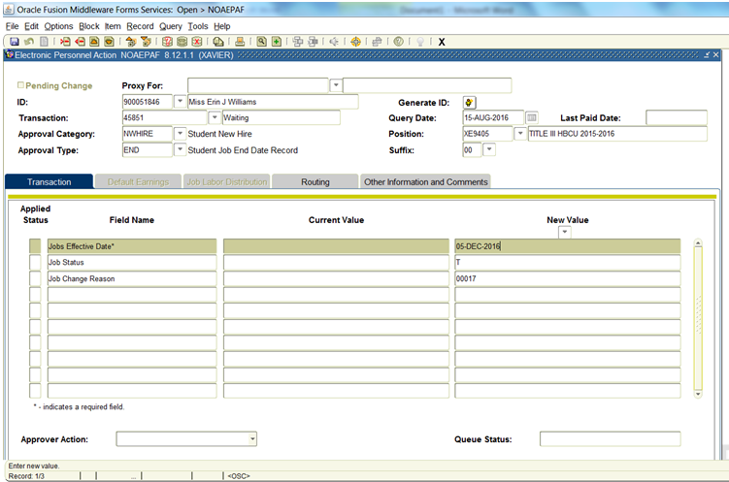

**21.**

**20.**

**19.**

**18.**

|  |  |  |  |  |  |  |  |  |  |
| --- | --- | --- | --- | --- | --- | --- | --- | --- | --- |
| **Step 19.** Entering the Employee’s **Job Detail Information** to End the Job | |  |  | | --- | --- | | **Field Name** | **Description** | | **Jobs Effective Date** | Enter thedate the funding and position should end. This date must be later than the date that you wanted to start paying the employee from this fund.  **Note:** Please be sure to view the academic and biweekly pay period calendars to select the best end date. | | **Job Status** | Default is **“T”** | | **Job Change Reason** | Default is **“00017”** |   Enter the data listed below in the **“New Value”** column based on the data requested in the **“Field Name”** column. |
| **Step 20. Save** the Data Entered | Click the **“Save”** icon to commit the data entered |
| **Step 21.** | Click the “**Routing”** Tab |

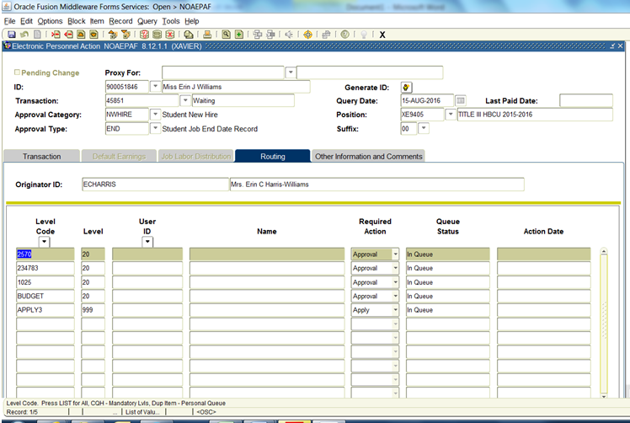

**23.**

**22.**

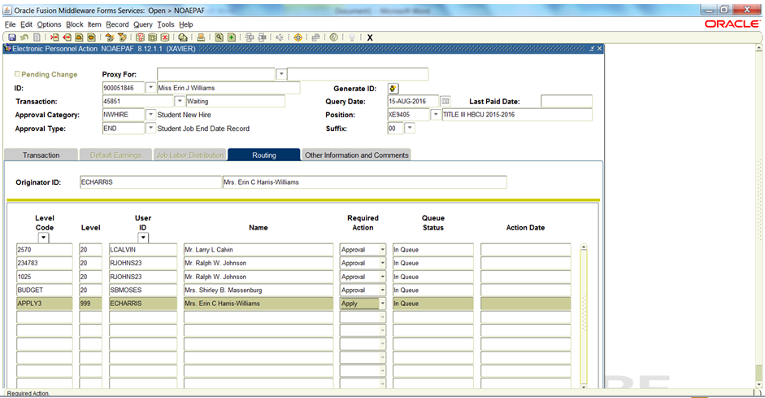

|  |  |  |  |  |  |  |  |  |  |
| --- | --- | --- | --- | --- | --- | --- | --- | --- | --- |
| **Step 22.** Populate the **Routing Tab**  (User ID must be populated for each pre-defined Level Code present in the Routing Tab) | |  |  | | --- | --- | | **Routing Tab Fields** | **Description** | | **Level Code** | Defaults all Approvers’ Level Codes | | **User ID** | Tab to the blank field in the User ID Column. Click the “**User ID”** drop down arrow. The Banner Client User ID for the individual responsible for approving for that level code will appear automatically. | | **Required Action** | Field is automatically populated with the action the Approver is required to take: ***Approval***, FYI or Apply.  **Warning:** Do not change the required action status. Doing so will result in the ePAF being returned to the Originator by HR for correction. | |
| **Step 23. Save** the Data Entered | Click the **“Save”** icon to commit the data entered |

**VI. Entering Additional Information for Job Details**

Additional information about a transaction can be inserted on the “Other Information and Comments” tab. Detailed below are the steps that are required to submit a transaction.

**25.**

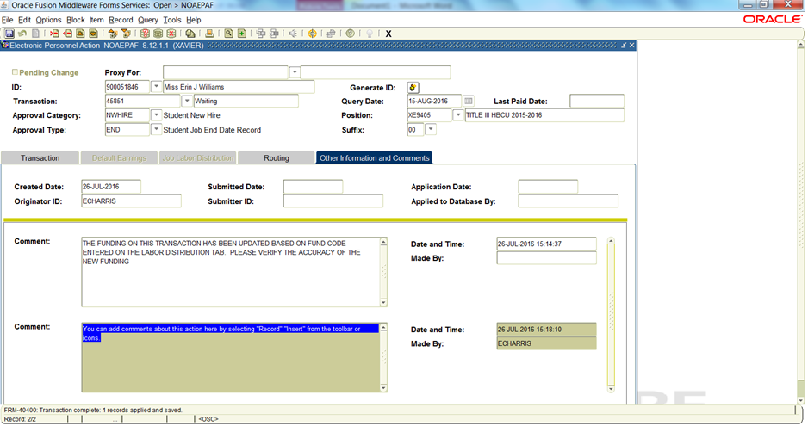

**26.**

**24.**

|  |  |
| --- | --- |
| **Step 24.** Options for Additional **Comments** | Click the **Other Information and Routing** Tab |
| **Step 25.** | Click **“Record Insert”** from the Toolbar or Icons to enter an empty comment box.  **Note:** You can enter comments about any job details that could not be recorded without error on the job details of the ePAF (i.e., Salary Amount, Supervisor’s ID, Off-Campus and Hybrid Job Location Sites, Special Notes to Approvers for consideration) |
| **Step 26. Save** the Data Entered | Click the **“Save”** icon to commit the data entered |

**VII. Submitting the Transaction for Approvals**

Submitting an ePAF transaction for approval routing is the final step in originating a

transaction. Detailed below are the steps that are required to submit a transaction.

**27.**

**28.**

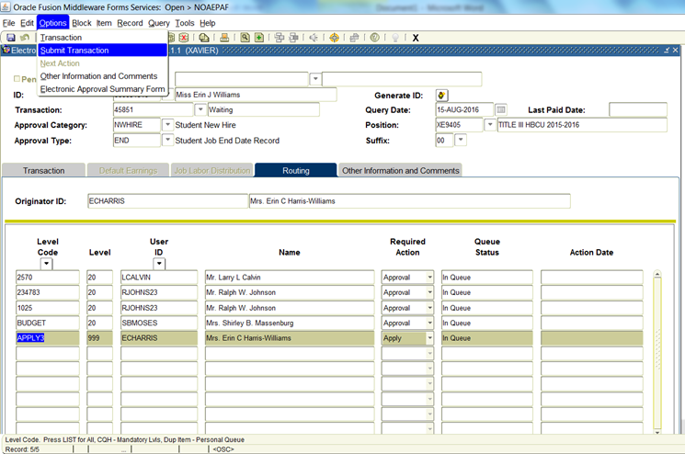

**28.**

**Transaction Submitted.**

**27.**

**Pending**

Message Bar

|  |  |
| --- | --- |
| **Step 27.** | 1. Click the **Routing** Tab again  2. Click **“Options”** from the Toolbar and select **“Submit Transaction”**  **Note:** If your submission was successful **“Transaction Submitted”** should appear in the message bar at the bottom of the form and the Transaction Status should display **“Pending”** |
| **Step 28.** | 1. To originate the next ePAF, click **“Rollback”** from the Icons to return to the Key Block information.  2. Click **“Record Clear”** from the Toolbar to clear out the current employees Key Block information and enter the next employee’s XUID to begin originating the next ePAF. |

**Errors and Warnings Details**

**Identifying and Correcting ePAF Errors and Warnings**

If you have made any errors in the transaction, error and warning messages will be displayed on the Error and Warning Detail Form (NOIEMSG). You will be automatically directed to this page upon your attempt to submit if errors exist.



**1.**

**5.**

**2.**

**3.**

**4.**

**45775**

|  |  |
| --- | --- |
| **Step 1.** | Click **“Next Block”** from the Toolbar or Icons to view the Errors and Warning Information |
| **Step 2.** | View the Approval Type. This will provide tips for which action the error exists on. |
| **Step 3.** | View the Error Type. This will confirm whether there is an error or a warning. Errors must be corrected before you will be able to move on to “Submitting” the transaction. |
| **Step 4.** | View Errors and Warnings Information for a description of the error that must be corrected |
| **Step 5.** | Click the Exit and return to the identified Approval Type to correct any mistakes on the transaction and then select **“Submit Transaction”** from the **“Options”** Toolbar again until all errors have been cleared and the transaction is successfully submitted. |

**Common Errors and Warnings**

***\*WARNING* Rate for this job is outside the Table/Grade range.***This warning may be disregarded because certain positions use one “pooled” position # and cannot be assigned a specific salary grade or range.

***\*WARNING* Future changes exist starting MM/DD/YYYY.***

**Problem:** This warning indicates that the employee has records in Banner Client on this same position # and suffix for perhaps a different Unit that has been applied to the database with a future date.   
  
**Solution:** Remove this transaction and contact HR for advice on how to enter a new position on the same position number with different attributes.

***\*ERROR* Rate times factor times hours per pay does not equal Annual Salary.***

**Problem:** This error means that the Salary Amount that you are paying the employee divided by the number of pays is not properly calculating the Assigned Salary Amount (Salary Amount/Factor = Assigned Salary).

**Solution:** Remove the Salary Amount from the field on the Approval Type START and insert it in the comments under the Other Information and Comments tab about the salary amount that you wish to pay for the assigned period (i.e., Salary Amount = $1000)

# *\*ERROR* Future-dated job must be deleted before ending Job.*

**Problem:** The employee has a future transaction in NBAJOBS with an end date that conflicts with the one that you are entering. HR will need to remove that record before you can submit the termination record in NBAJOBS before you can enter a new ePAF to extend the end date.

**Solution:** Contact HR to have the transaction removed.

***\*ERROR* Begin Date must equal the first Jobs Detail Effective Date.***

**Problem:** This error is caused by what Banner considers to be a conflict in the **Job Begin Date** field. **Job Begin Date** signals the *first* date that the employee received the position # and suffix combination that you are now again assigning to him/her.

**Solution:** To resolve the error, find the date listed in the **Current Value** column (to the left of the open field in the **New Value** column) and reenter this date in the **New Value** column or leave this field blank when using REHIRE Approval Category.

***\*ERROR* This employee already has a primary job.***

**Problem:** Each employee can only have one primary job

**Solution:** Contact HR to confirm whether it is approved for the employee to have a Secondary Contract Type. Student employee assigned to Federal Workstudy cannot work other work program on campus; however, it is ok for Departmental Hire Program employees to work multiple jobs as long as work hours do not overlap and hours do not exceed the allowable maximum of 20 hours per week during a enrollment periods and maximum 40 hours per week during non-enrollment periods (see policy guide for more details on allowable work hours).

***\*ERROR*Job Detail record must exist to create a new job.***

**Problem:** This error indicates that you are trying to amend a job that does not yet exist by using **REHIRE** Approval Category for a new employee who has never worked on this position in your Unit before.

**Solution:** If you have entered a new position # and suffix, please void your EPAF and begin again, keeping the aforementioned in mind. If you are trying to create a new assignment, please use the appropriate **NWHIRE** Approval Category.

***\*ERROR* Invalid Supervisor ID.***

**Problem:** This error indicates that the Supervisor ID entered on the ePAF is either an invalid XUID number or that the Supervisor being assigned does not “himself” have an ePAF for employment that accommodates the hire dates of the student employee.

**Solution:** Please verify the XUID number for the Supervisor and re-enter on the ePAF or contact the Faculty/Staff Compensation Analyst at ext. 5724 to assist with the information needed to originate an ePAF for the Supervisor first. To continue processing the student’s ePAF, remove the Supervisor’s ID and add a comment in the “Other Information and Comments” tab that indicates

**Note:** All ePAFs, Faculty/Staff/Students, are used to: 1.) Identify active employees of the University and should not terminate without a new action being originated in advance of the termination date if the employee will not have breaks in his employment with the University 2.) Identify job details such salary information, funding information, and job location before an employee can begin or continue working with the University in a particular Unit and have access to the timekeeping tool Banner Web Time Entry (WTE).

***\*ERROR* First Name, SSN/SIN, Birth Date or Gender incomplete.***

**Problem:** This error indicates that a required personnel field on the Information PPAIDEN Banner Client Form is missing.

**Solution:** Please contact your designated HR to proceed with the ePAF.

**Note:** Be sure to verify the employee’s proper XUID number prior to contacting HR.

**Approve Transactions**

ePAF transactions require approvals at the Principle Investigator of Funds, Fiscal Services, Unit (Organization Code), and College (CAS or COP), levels. HR reviews and applies the records after all approvals are complete. Approvers are notified via automatic notification by email as soon as ePAFs are originated and immediate action should be taken on the transaction as ePAF approvals do not happen hierarchically, but laterally. When initiated as an ePAF Approver, ePAF approvals must be incorporated into your daily tasks in order to ensure that employees are able to report to work upon the scheduled start date of the position. Delays in approvals can result in delays of employment. ePAFs can be approved on Banner Form NOAEPAF or NOAAPSM.

**Option 1-Approve Transactions on the NOAEPAF Form**

1. Log into Banner Client with your Username and Password.Access the Electronic Personnel Action Form (NOAEPAF).
2. Enter the XUID for whom the transaction is to be approved.
3. Select the ePAF transactionnumber that you want to approve.

(You can use the Search feature for the “Transaction” field to display a list of transactions for the selected person and you can then select transaction from that list.)

1. If the queue status is *Pending*, examine the transaction to determine whether it is ready for approval. If the queue status is anything other than *Pending*, the procedure is complete at this point.
2. To approve the transaction, select *Approve* from the **Approver Action** drop down arrow and Save. The transaction status and queue status become Approved.

(If the transaction contains incorrect information for the person, select *Return for Correction* from the **Approver Action** drop down arrow and Save.)

**Option 2-Approve Transaction on NOAAPSM Form**

1. Log into Banner Client with your Username and Password.
2. Access the Electronic Approval Summary Form (NOAAPSM) in Banner Client.
3. (Optional) Enter the first date of the period for which submitted transactions are to be approved in the **Submitted From Date** field.
4. (Optional) Enter the last date of the period for which submitted transactions are to be approved in the **Submitted To Date** field.
5. Select *Pending* from the **Transaction Status** drop down arrow.
6. Select *Pending* from the **Queue Status** drop down arrow.
7. Go to the next block. All transactions (if any) that meet the criteria specified in the key block are displayed. If no transactions meet these criteria, the procedure is complete at this point.
8. Review each transaction that you plan to approve as follows:

7.1 Select the transaction

7.2 Then access the NOAEPAF form for the transaction by selecting *PAF Detail Information* from **Options** on the Toolbar

7.3 Examine the transaction on NOAEPAF

7.4 Finally, return to NOAAPSM by exiting NOAEPAF

1. Select *Approve* from the **Approver Action** drop down arrow for each transaction that you want to approve.

(Select *Return for Correction* for each transaction where information is correct.)

1. Save. The transaction status and queue status for each approved transaction becomes *Approved*.

## Frequently Asked Questions

**1.** **I am ready to take a Personnel Action using ePAF, What do I have to do?**

## 2. What is the difference between when a transaction is “saved” and when a transaction is “submitted”?

**3. How do I customize my view so that I only see ePAFs that I can take action on?**

**4. Can I see all ePAFs that are originated from my Unit?**

**5. How do I know with certainty that an ePAF has been submitted?**

**6. What are the Originators’ responsibilities?**

**7. What are the Approvers’ responsibilities?**

**8. What are proxies?**

**9. Can an Originator have proxies?**

**10.** **Can an Approver have proxies?**

**11. Can an Approver also be an Originator?**

**12.** **How will I know who has approved my ePAF?**

**13. Can a Faculty/Staff/Student have more than one Primary Position?**

**14. Can a Faculty/Staff/Student have more than one Secondary Position number?**

**15. What is a Secondary Position?**

**16. Can I add and delete Approval Levels on the “Routing” tab?**

**17. What do I do if I notice that there is an incorrect person listed in the Approval Routing on the “Routing” tab?**

**18.** **How can I search for a Supervisor’s ID?**

**Q1. I am ready to take a Personnel Action using ePAF, what do I have to do?**

1. First you should check to ensure that you have access to the required Banner Client forms. If you do not have access, please contact the student ePAF Administrator at ext 5738. After you have accessed the form.

**Q2. What is the difference between when a transaction is “saved” and when a transaction is “submitted”?**

1. **Saving a Transaction**

Saving a transaction only allows you to commit the information that you have entered thus far on the ePAF form. The first time a transaction is “Saved”, the system will automatically assign a transaction number and change the Transaction Status to “Waiting”. The transaction does not go into the approval queue for Approvers to view or take an action on the transaction. To save a transaction, click the “Save” Icon.

1. **Submitting a Transaction**

Submitting a transaction changes the status of the transaction from “Waiting” to “Pending” and the transaction is placed in the routing queue of the individuals defined on the routing tab of ePAF to Approve immediately.

**Submit Option**

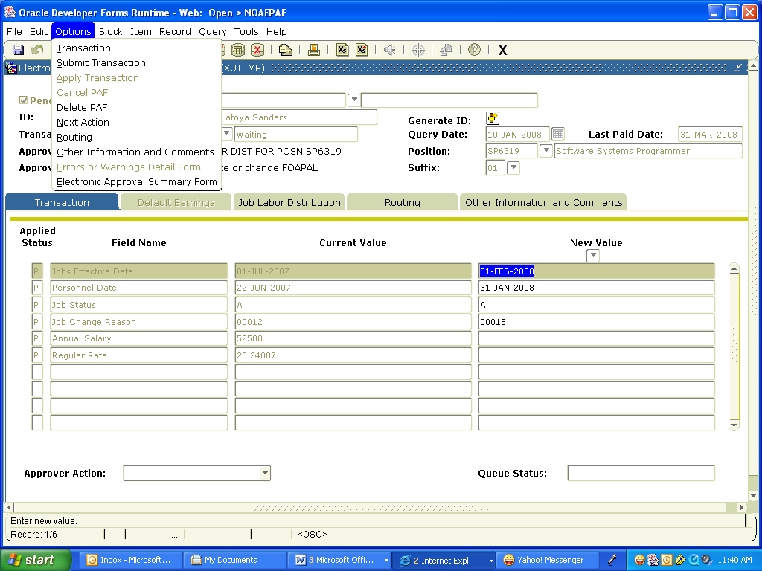

**Save Icon**

## Q3. How do I customize my view so that I only see ePAFs that I can take action on?

1. If you are designated as an Approver, you can go to the Approval Summary form **NOAAPSM.** On that form setthe Transaction Status to “**Pending”** and the Queue Status to **“Pending**”. Setting both statuses to “Pending” will return all of the transactions that you are required to take action on with a Transaction status of “Pending” and a Queue Status of “Pending”.

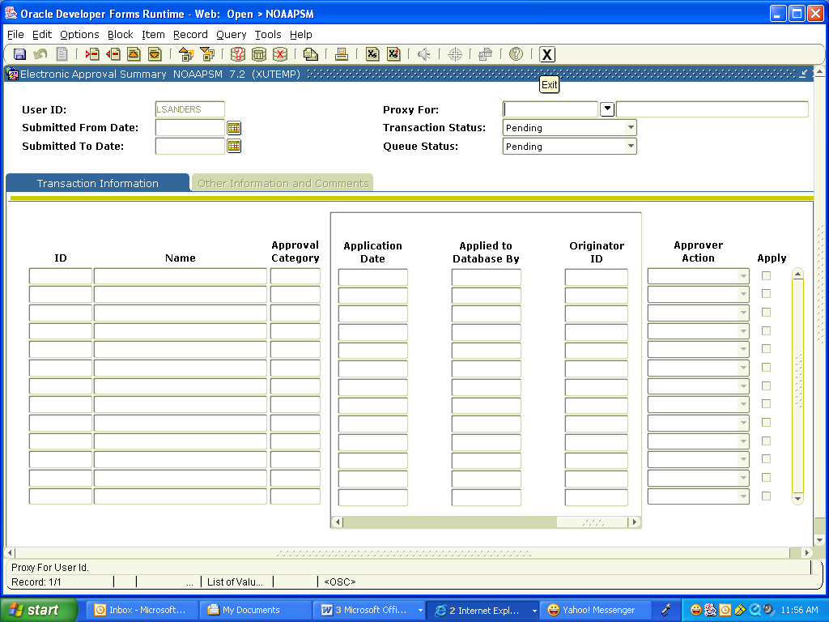

**Status of the Transaction**

**Status of the transaction in your queue**

## Q4. How do I see all ePAFs originated from my Unit?

1. Unfortunately, no one person can see all of the ePAFs for a specific Unit from either the Approval Summary Form (NOAAPSM) or Electronic Personnel Action Form (NOAEPAF). However an individual can see all of the ePAFs that he/she has been designated to take an action on or has originated. If you are designated as an Approver, you can go to the form Approval Summary from **NOAAPSM.** On that form setthe Transaction Status to “**All”** and the Queue Status to **“All**”. Setting both statuses to “All” will return every ePAF that you have ever been designated to take action on, regardless of the Transaction or Queue statuses.

## Q5. How do I know with certainty that an ePAF has been submitted?

1. The message area will return the message Transaction Submitted, and the transaction status changes from **Waiting** to **Pending** and the transaction can be seen on the Approval Summary Form (**NOAAPSM**).

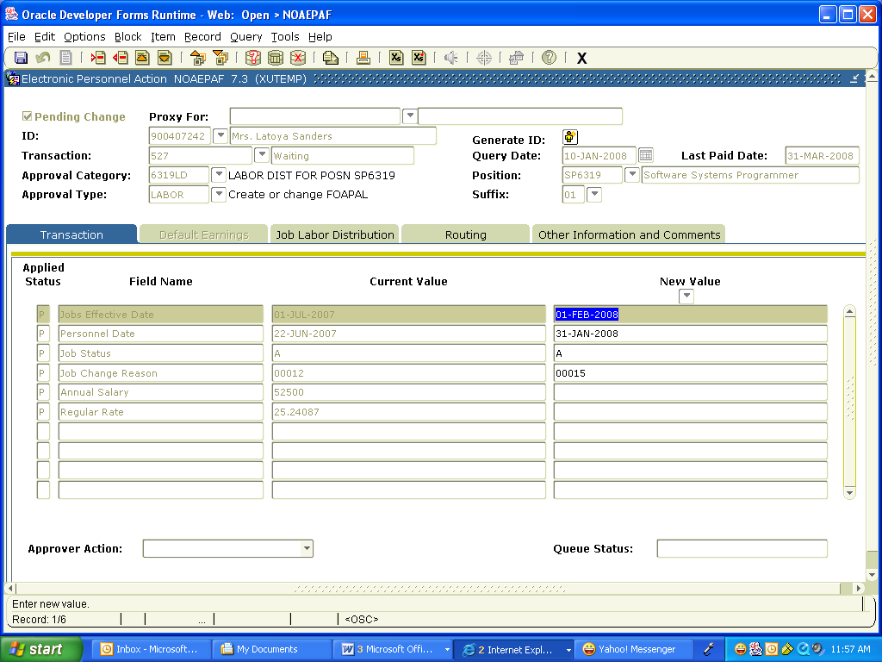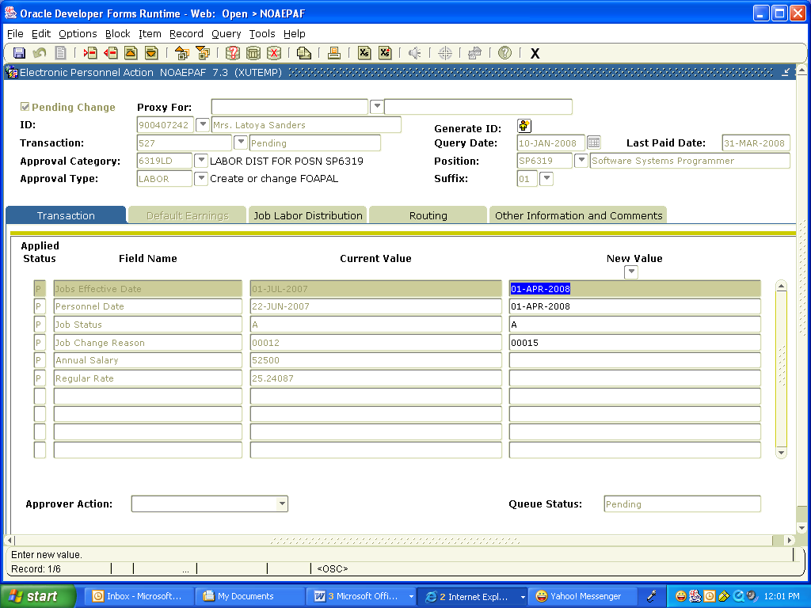

**Data in ePAF has been “Saved”, but not yet Submitted**

**Transaction has been “Submitted”**

## Q6. What are the Originators’ responsibilities?

1. The “Originator” is responsible for accurately entering all the job detailed information on the ePAF. The Originator should check the status of their **ePAFs** transaction on a regular basis.

## Q7. What are the Approvers’ responsibilities?

1. “Approvers” are responsible for checking the Approval Summary form **NOAAPSM** for any transaction with Transaction and Queue Statuses of “Pending” on a daily basis. Approvers also have the ability to Return for Correction or Disapproved actions for additional information on to be performed by the Originator if necessary.

## Q8. What are proxies?

1. Individuals authorized to take approval action in the absence of the Approver. Contact HR to establish proxies.

## Q9. Can an Originator have proxies?

1. **Yes!** The proxy of an Originator can update or change data on an ePAF in which he or she did not originate as long as the transaction’s status is “Pending” or “Return for Correction” in the Originator’s absence.

**Q10.** **Can an Approver have proxies?**

1. **Yes!** For details on how to take an action as a Proxy for an.

**Q11.** **Can an Approver also be an Originator?**

1. **Yes!** An Approver can also be an Originator as long as he or she request both Approver and Originator access to the forms NOAEPAF/NOAAPSM in Banner Client from HR.

**Q12.** **How will I know who has approved my ePAF?**

1. Go to the form **NOAEPAF,** enter the transaction number and click the routing tab**.** The “Queue Status” column next to each individuals name will give the status of the transaction in their queue. The “Action Date” field will also be populated with the date the individual made the action. Those deficient will remain blank until that Approver takes action. You may need to contact an Approver for action if the ePAF has not being approved timely.

**Q13.** **Can a Faculty/Staff/Student have more than one Primary Position?**

1. No a Faculty/Staff/Student can only have one active Primary Position in Banner Client.

**Q14.** **Can a Faculty/Staff/Student have more than one Secondary Position number?**

1. Yes a Faculty/Staff/Student can have more than one active Secondary Position number. See the student employment policies about available work hours.

**Q15.** **What is a Secondary Position?**

1. It is a position that a Faculty/Staff/Student has in addition to his/her primary position. If a student is an employee of the Federal Work Study (FWS) program, he/she cannot work a secondary job at XU.

**Q16.** **Can I add and delete Level Codes on the “Routing” tab?**

1. Level Codes cannot be deleted from the Routing Tab. If a code needs to be deleted you must notify Human Resources via e-mail regarding the change and Human Resources will update the routing on your behalf. The individuals defined in the routing have a responsibility from the Principle Investigator, College (CAS or COP), Unit, Fiscal, and HR levels and must not be removed or added as level codes are automatic.

**Q17.** **What do I do if I notice that there is an incorrect person listed in the Approval**

**Routing on the “Routing” tab?**

1. If you observe that an incorrect person is listed on the “Routing Tab” for a transaction either as an Originator or an Approver, contact Human Resources immediately at ext. 5738.

**Q18.** **How can I search for a Supervisor’s ID?**

1. Please gather this information from the Supervisor when gather other data about the job details before you begin originating the ePAF.

Enter the Supervisor’s Last name