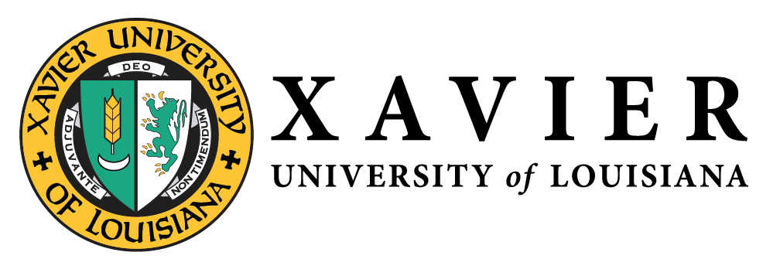
National Alumni Association
1 Drexel Drive, Box 66 • New Orleans, Louisiana 70125 • (504) 520-7575 • FAX (504) 520-7915

NATIONAL ALUMNI  OFFICERS 2019-2021  1 Drexel Drive  Campus Box 66  New Orleans, LA 70125  (504) 520-6782  1-877-WE LUV XU  Mr. Randall McHenry’86  President  randall@mchenryinc.net  Mr. Trevonne Thompson’97  1st Vice President  Trevonne.thompson@gmail.com  Ms. Chakita Holmes’03  2nd Vice President  chakitaholmes@yahoo.com  Dr. Nicole M. Golden’00  Corresponding Secretary  ndmarchand@gmail.com  Ms. Tiffany Devereaux’98  Recording Secretary  ttdex@yahoo.com  Mr. Kevin Barnes’11  Treasurer  kevinlbarnes@bellsouth.net | May 5, 2020  “If we serve God and love our neighbor well, we must manifest our joy in the service we render to Him and them. Let us open wide our hearts. It is joy which invites us. Press forward and fear nothing.”  -Katharine Drexel  Dear:  The future is hard to predict. But one thing we do know is that we will need resources to fuel the mission of Saint Katharine Drexel in years to come. As Xavier University of Louisiana approaches its 100-year anniversary, the National Alumni Association is establishing an endowment fund for scholarships, in Memory of Sr. Monica Loughlin, SBS (11/13/43-2/28/19), who had a long tenure at Xavier as a student, faculty member and administrator. The goal of $1,000,000 is to be raised by January 2025, the 100th Anniversary of Xavier University of Louisiana.  By creating an endowment fund for scholarships, our legacy as alumni will be invested for the benefit of our alma mater and scholarships for future Xavierites. It is a long-term, permanent fund that provides income each year to support future students attending the university. Up to 5% of the investment earnings will be contributed to General Scholarships to help needy students each year, with all earnings above the 5% being reinvested into the principal or corpus of the endowment.  We invite you to make a gift of a minimum of $5,000 which may be paid over the next five years to facilitate meeting our goal by Xavier’s 100-year anniversary. Here’s how you can participate:  - One-time gift of a minimum of $5,000  - Annual $1,000 gift over five years  - Ten $500 gifts bi-annually  - Twenty $250 gifts quarterly  - Monthly gift of $83.33 over 60 months  Please return the confidential response card and become a “Centennial Endowment Donor” today! As a Centennial Endowment Donor, you will receive a commemorative pin to wear with pride and your name will be forever memorialized on a plaque displayed on the university’s campus. (*The plaque will be revealed at the 100-year anniversary celebration in 2025.) All pledges of $5,000 must be paid by June 30, 2025 to be recognized as a “Centennial Endowment Donor.”  Whether or not we write our memoirs, in the end we are all remembered for our acts – for the lives we touch and by the causes we advance. Please join your fellow alumni in creating a lasting legacy in Honor of Sr. Monica Loughlin, SBS, by making a meaningful gift to the National Alumni Association endowment fund. The future depends on us.  You may contact Keith Blossom, Development Officer, at 504-520-6795 or kblossom@xula.edu for additional information or questions.  Thank you for your thoughtful consideration,  Randall McHenry ‘86  Xavier University of Louisiana National Alumni Association, President

