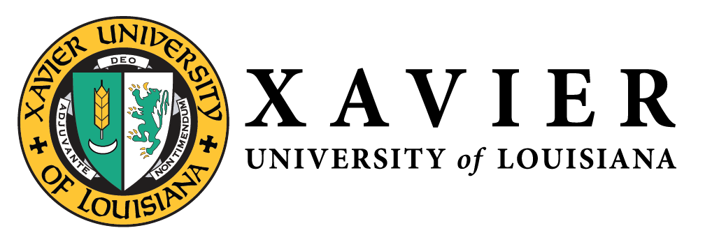
National Alumni Association
1 Drexel Drive, Box 66 • New Orleans, Louisiana 70125 • (504) 520-7575 • FAX (504) 520-7915

NATIONAL ALUMNI  OFFICERS 2019-2020  1 Drexel Drive  Campus Box 66  New Orleans, LA 70125  (504) 520-6782  1-877-WE LUV XU  Mr. Randall McHenry’86  President  randall@mchenryinc.net  Dr. Trevonne Thompson’97  1st Vice President  Trevonne.thompson@gmail.com  Ms. Chakita Holmes’03  2nd Vice President  chakitaholmes@gmail.com  Nicole M. Golden’00  Corresponding Secretary  ndmarchand@gmail.com  Ms. Tiffany Devereaux’98  Recording Secretary  ttdex@yahoo.com  Mr. Kevin Barnes’10  Treasurer  kevinlbarnesjr@gmail.com  Gwen Charles’80  Parliamentarian  gwendolyn.charles@gmail.com | Chapter Updates  - New England Charter (Courtney Scrubbs ‘04)  - Held first general body meeting, May 3rd  - Elected four (4) office(Office of President Vice President, Treasurer, and Secretary)  - Participated in #GLX2020 and raised approximately $1850  - St. Louis, MO (Rosalyn Crain Tinnin ‘01)  - Targeting to have elections in June 2020  - Hosted XU Comes to You Admission event on February 8th  - Baton Rouge, LA (Branden Weber ‘03 & Karen Yarbrough ‘86) - Interest Meeting is scheduled for May 14th

