**Banner Web Time Entry  
Supervisor Guide**

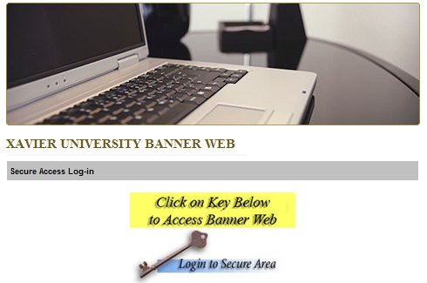

**Office of Human Resources**

**Table of Contents**

|  |  |
| --- | --- |
| **Table of Contents** | **2** |
| **Prerequisites for WTE** | **3** |
| **WTE Roles** | **3** |
| **Accessing WTE** | **4-5** |
| **Selecting Timecards** | **6-7** |
| **Summary of Timecards** | **8-9** |
| **Adjusting Timecards** | **10-11** |
| **WTE 7-Minute Rule** | **11** |
| **Crossing Midnight Clock In/Out** | **11** |
| **Approving Timecards** | **12** |
| **Verifying Approval of Timecard** | **13** |
| **WTE Definitions** | **14** |
| **WTE Status Displays** | **15** |
| **WTE Buttons/Icon** | **16** |
| **FAQs** | **17-18** |

**For Training Needs or Help with WTE Contact:  
Office of Human Resources   
Student Web Time Entry Administrator  
Ext. 5738**

**Prerequisites for Web Time Entry (WTE)**

1. Supervisor must have a User Code for Banner Client in order to access timecards in WTE
2. Supervisor must confirm the student’s status as being currently enrolled at Xavier in a degree seeking program
3. Students are not allowed to begin working in a unit, until a ‘Completed Status ePAF’ report is sent to the originator of the ePAF via automatic notification at 6pm on the date the ePAF reaches complete status. This report authorizes the student as an official employee of the University and informs the originator that a timecard is available in Web Time Entry (WTE) to begin clocking time. It is a violation of student employee and Federal policies to allow a student to work without authorization first.
4. Supervisor will need to know his/her own XUID number and Banner Web PIN to access timecards
5. Unit will need to have a computer that the employee can use to access WTE if the student is identified through ePAF as an on-campus location employee
6. Employee will need to be able to log into Banner Web using his/her own credentials from a workstation that is logged onto the employee network by a Supervisor or designated Faculty/Staff member in the Unit

**WTE Roles**

**Originator-Student Employees**   
Abilities:

* + Clock in/out
  + Preview Timecards
  + Comment in Timecards
  + Submit Time

**Approver-Supervisors**Abilities:

* + Preview Timecards
  + Comment in Timecards
  + Adjust Time
  + Submit Time (extenuating circumstances)
  + Approve Time

**Note:** A supervisor proxy can be established by contacting HR in the event that the supervisor forecasts absence or unavailability of internet services

**Acknowledger-HR**  
Abilities:

* + Review/Acknowledge Timecards for Policy

**Accessing WTE**

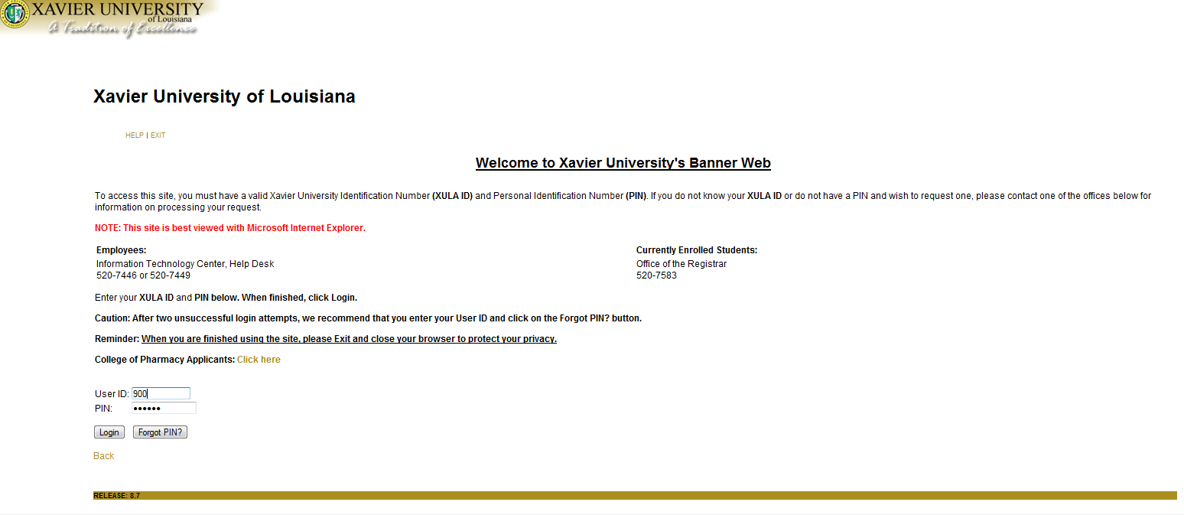

|  |  |
| --- | --- |
| **Step 1. User ID** | Enter your XUID **900#** |
| **Step 2. PIN** | Enter your **mmddyy** Date of Birth for initial access (should change PIN for your protection) |
|  | Press **‘Login’** |

**Note:** Banner Web User ID and PIN sharing is prohibited.

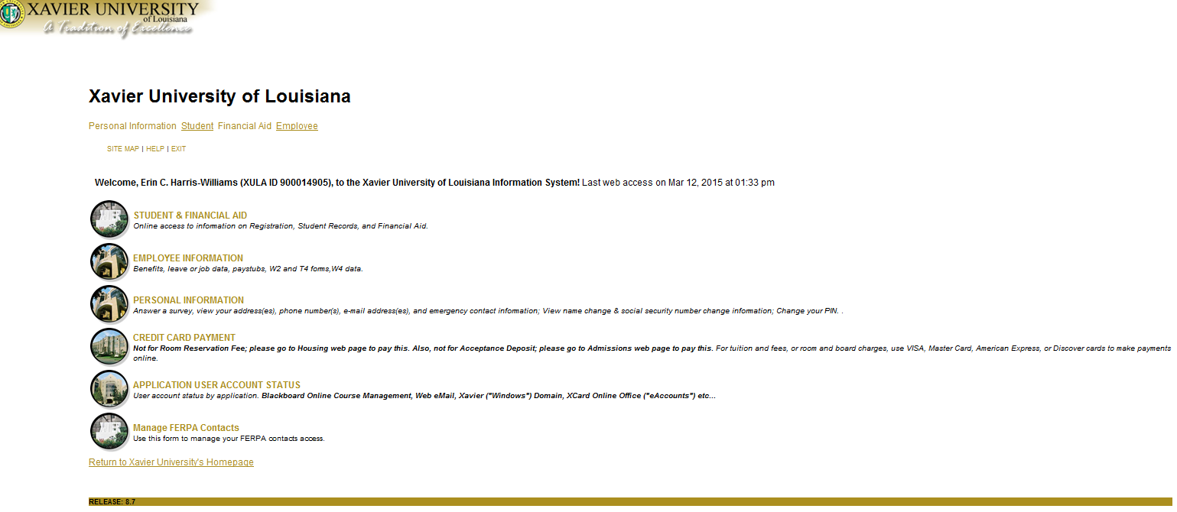

**Your Name is Here**

|  |  |
| --- | --- |
| **Step 3. Employee Information** | Click on the link, **‘Employee’** or **‘Employee Information’** |

**Accessing WTE (Cont’d)**



|  |  |
| --- | --- |
| **Step 4. Time Sheet** | Click on the link, **‘Time Sheet’** |

**Selecting Timecards**

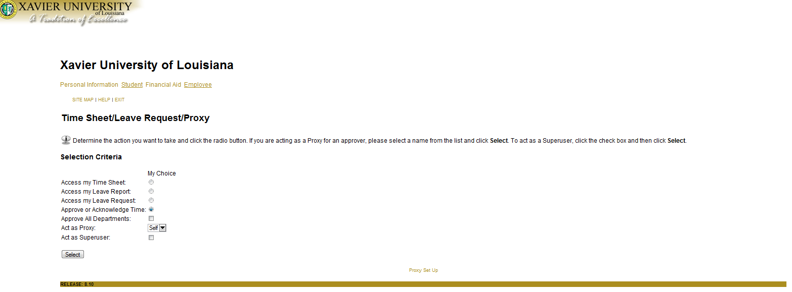**Timecard/Leave Request/Proxy Page**

**(5a)**

|  |  |
| --- | --- |
| **Step 5. Selection Criteria** | Default **‘Approve or Acknowledge Time’** to see your employees’ timecards |
|  | Press **‘Select’** |
| **Step 5a.** If you are acting as a supervisor’s proxy, if not skip to Step 6. | Select the drop down arrow next to **‘Act as Proxy’**; and select the supervisor you are acting as proxy for |

**Note:** The supervisor must contact HR to establish a proxy before one is needed. If the supervisor you are acting as proxy for is not listed in the drop down, have the supervisor contact HR to establish a proxy

**Note:** All WTE supervisors must have a Banner Client user code in order to access timecards

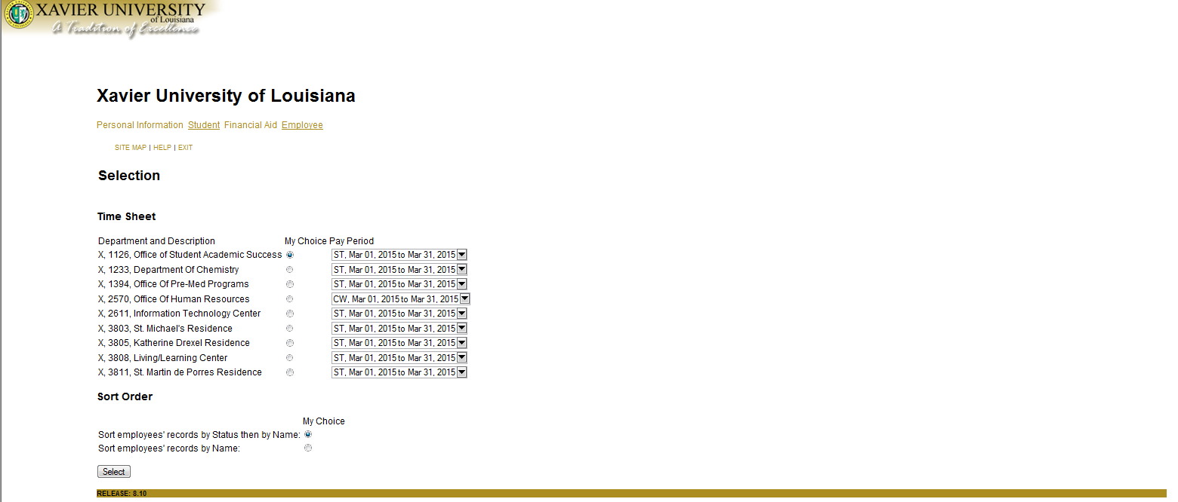

**Selecting Timecards (Cont’d)**

**Selection Page**

|  |  |
| --- | --- |
| **Step 6. Timecard Department and Description** | Includes 4-digit Organization Code and Department Name |
| **Step 7. My Choice Pay Period** | Defaults ‘Current Pay Period’  (Click down drop arrow to view historical data for pay periods) |
| **Step 8. Sort Order** | Option to select sorting method based on ‘Status and Name’ or by ‘Name’ only |
|  | Press **‘Select’** |

**Summary of Timecards**

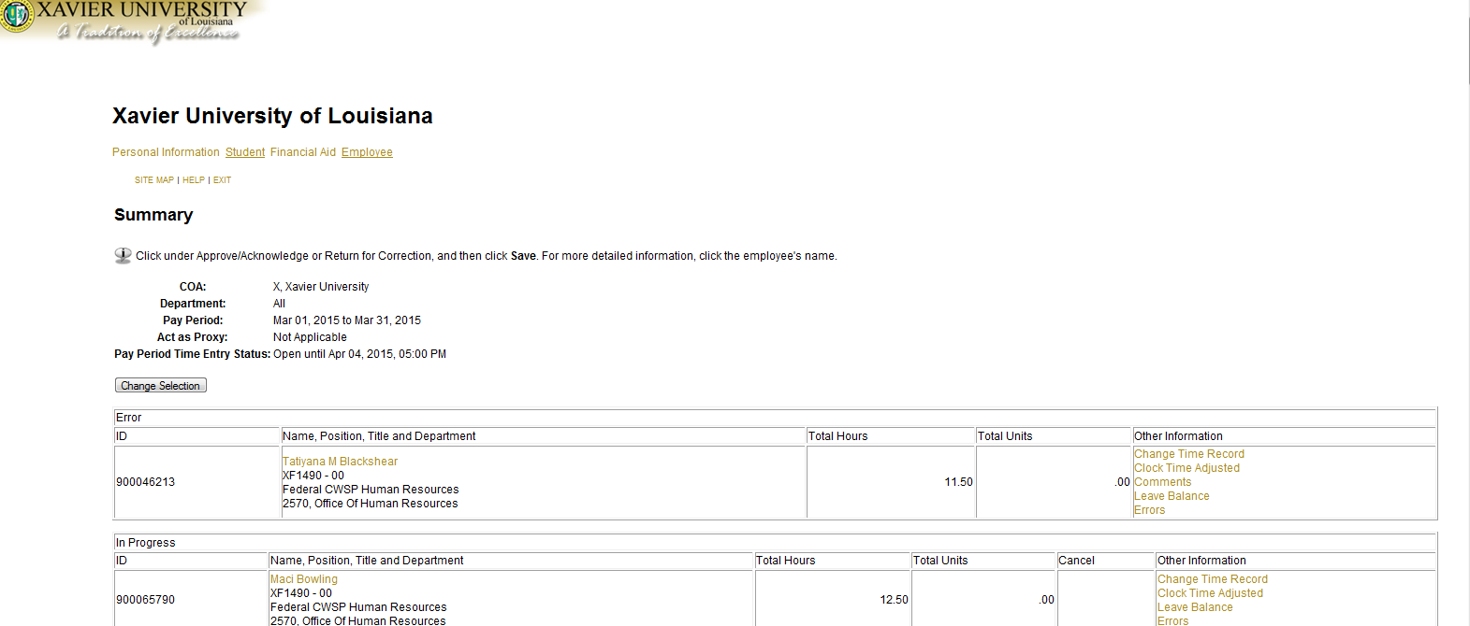

**Employee’s Name  
XF1490 – 00  
Federal CWSP Human Resources  
2570, Office of Human Resources**

**Summary Page**

|  |  |
| --- | --- |
| **Step 9. Employee’s Name** | Click on link for **‘Employee’s Name’** to see a detailed view on the Employee Detailed Information Page by individual employee (See Figure a. on page 9) |
| **Step 10. Change Time Record** | Click on link for **‘Change Time Record’** for the selected employee to manually adjust an employee’s timecard (See Figure b. on page 9)  **Warning:** Timecards should only be manually manipulated due to system errors or extenuating circumstances that prohibited the student from clocking in/out. This system is designed to capture time electronically. |

**Summary of Timecards (Cont’d)**

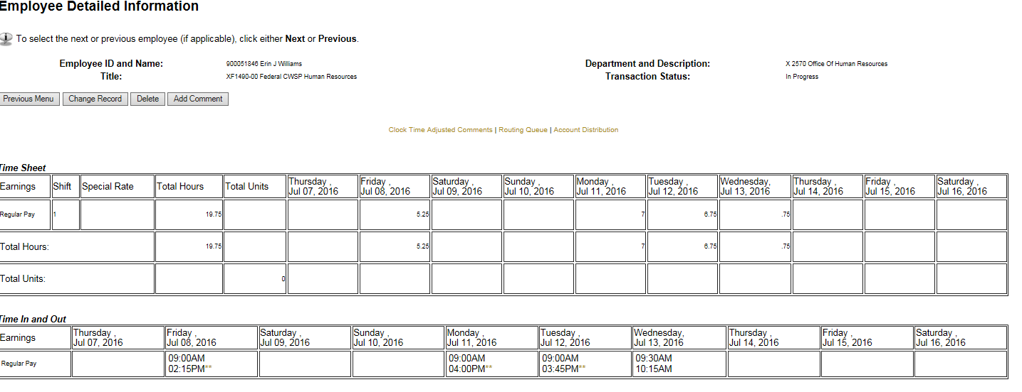

**XUID/Student’s Name**

**Employee Detailed Information View (Figure a.)**

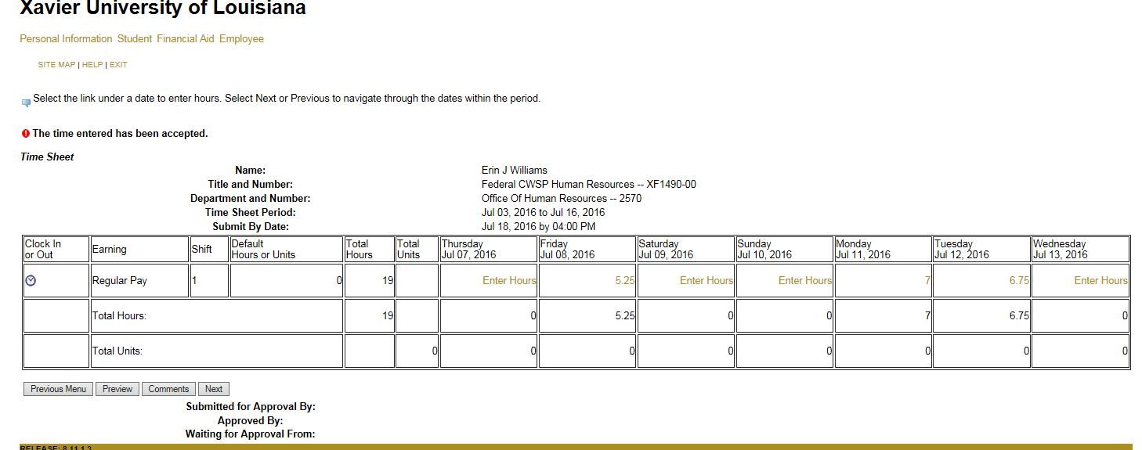

**Change Time Record View (Figure b.)**

**Adjusting Time Records**

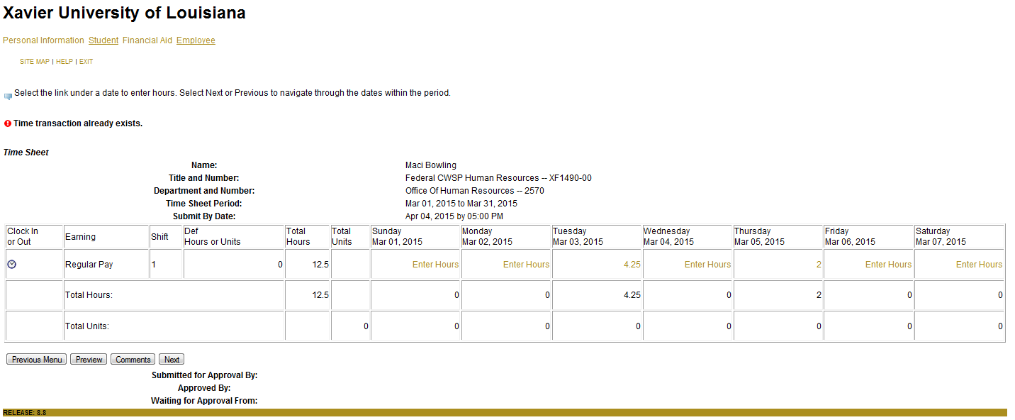  
Timecard Page

**XUID/Student’s Name**

**Shows Comments about Timecard Here**

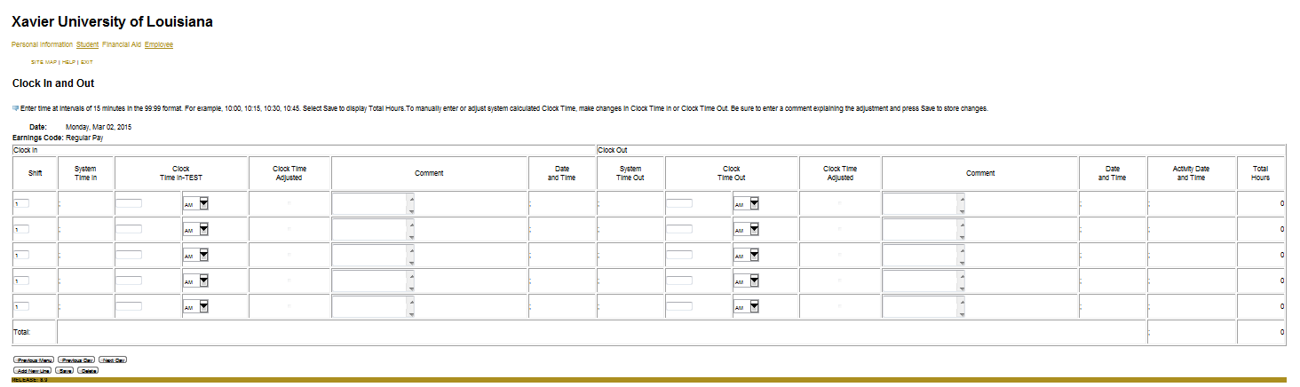  
Clock In and Out Page

|  |  |
| --- | --- |
| **Step 11. Enter Hours** | Click on link for **‘Enter Hours’** to adjust time records for a specific date  **Warning:** All manual entries capture user, time and date stamp, and require comments in both the clock time-in and clock time-out fields to document the reason for the occurrence. Multiple occurrences can result in disciplinary action by Human Resources. |
| **Step 12. Clock Time-In** | To manually adjust time, use a ‘**HH:MM’** format to enter the time. The system only recognizes time in 15 minute intervals (ex. 08:00, 08:15, 08:30, or 08:45).  **Note:** There is a 7-minute rule built into this system. 7-minutes *after* each quarter of an hour, the time will still measure at the nearest quarter; however 8-minutes *after* each quarter of an hour will round to the next quarter (ex. 08:00 AM-08:07 AM will measure 08:00 AM. However, 08:08 AM will round to 08:15 AM) |
|  | Click the drop down arrow to select **‘AM/PM’** |
| **Step 13. Comment** | Enter a descriptive comment of why the time is being manually adjusted in 60-characters or less |
| **Step 14. Clock Time-Out** | Follow Steps 12 above |
| **Step 15. Comment** | Follow Step 13 above |

**WTE’s 7 Minute Rule**

|  |  |
| --- | --- |
| **Time Range** | **Time that will be clocked** |
| 10:00am-10:07am | 10:00am |
| 10:08am-10:22am | 10:15am |
| 10:23am-10:37am | 10:30am |
| 10:38am-10:52am | 10:15am |
| 10:53am-11:07am | 11:00am |

**Note:** Clock times can only be recorded in 15 minute intervals (.00,.25,.50,.75)

**Note:** In case there is a system error, students are advised to keep a paper timecard with a record of their hours for internal uses that can be rerecorded by the supervisor in WTE.

**Clock In/Out that Passes Midnight to Next Day**

In cases where an employee’s work time passes from day one into day two, the webpage will assist in completing time records appropriately. If the employee had not clocked out from the previous day the webpage will ask *“Have you worked continuously through midnight?”* If the response to this question is ‘Yes’, the procedure will timestamp a Clock Out on the previous day at midnight and timestamp a Clock In on the current day at midnight. Further the procedure will assume that the employee is Clocking Out at the current system time. If the response to this question is ‘No’, you as the supervisor will need to adjust the previous day’s missed Clock Out to complete the previous day’s record, before the student will be allowed to Clock In on the current day.

**Approving Timecards**

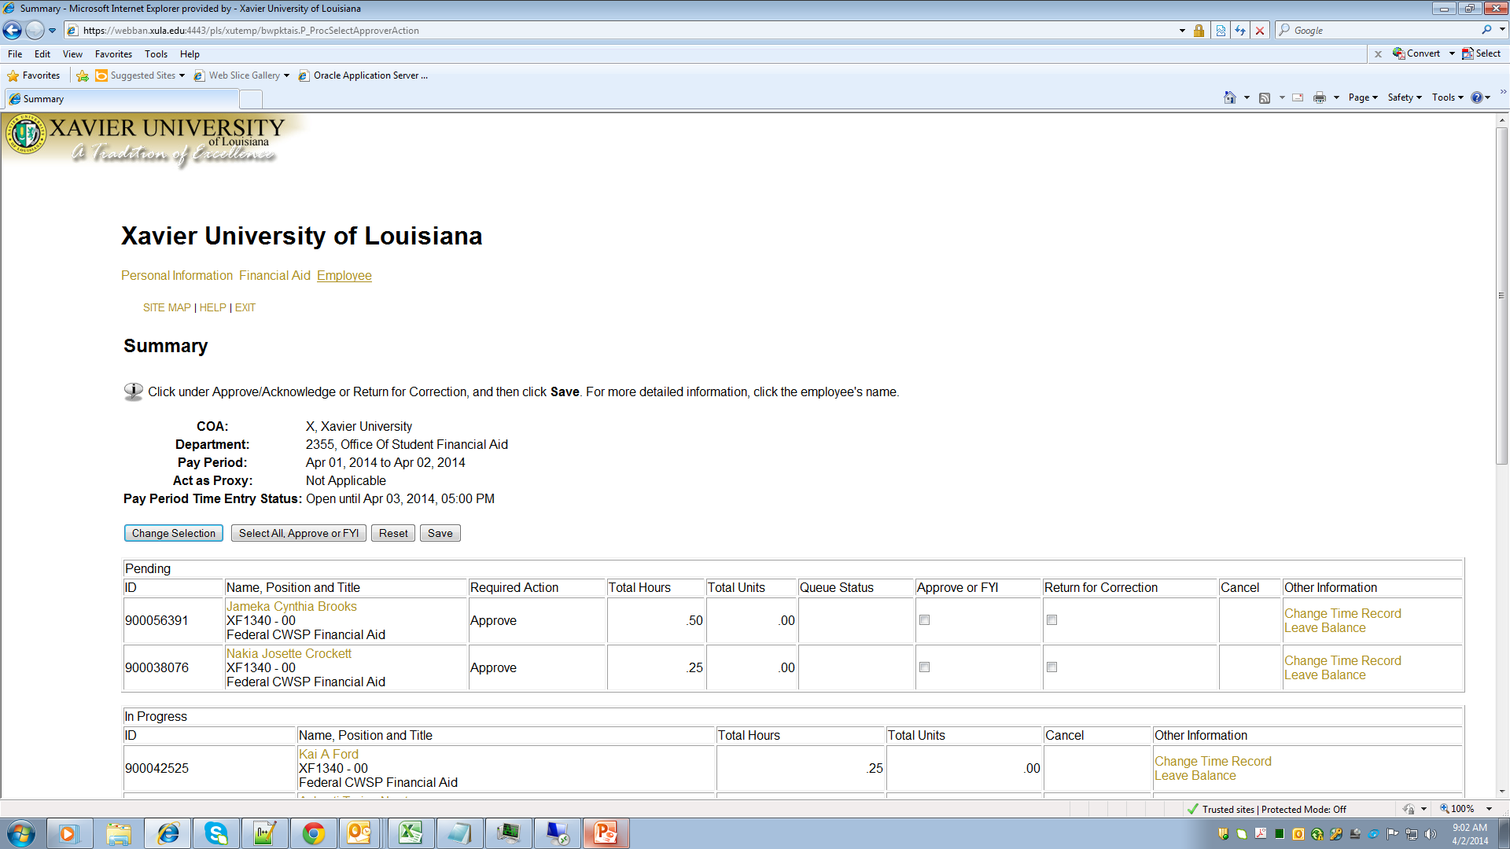

**Employee Information  
Position Information**

**Employee Information  
Position Information**

**Employee Information  
Position Information**

**Summary Page**

|  |  |
| --- | --- |
| **Step 16. Approve or FYI** | **‘Preview’** the timecards by clicking on the employees’ names individually. Press **‘Previous Menu’** and return to the Summary Page once previewing for accuracy is complete. Selecting **‘Approve or FYI’** will massively approve all the timecards you just previewed.  **Or**  You can put check mark in the box under the approve column for each individual timecard that you want to approve.  **Note:** All Supervisors are responsible for previewing timecards for accuracy before ‘Approving’ them for payroll. |
|  | Press **‘Save’** |

**Note:** Biweekly pay periods cover a designated two week period beginning on Sunday and ending two weeks later on Saturday. (June 19, 2016 to July 2, 2016) Supervisors must ‘Approve’ timecards by 4pm on the Monday following the pay period end date. (July 4, 2016)

**Verifying Approval of Timecards**

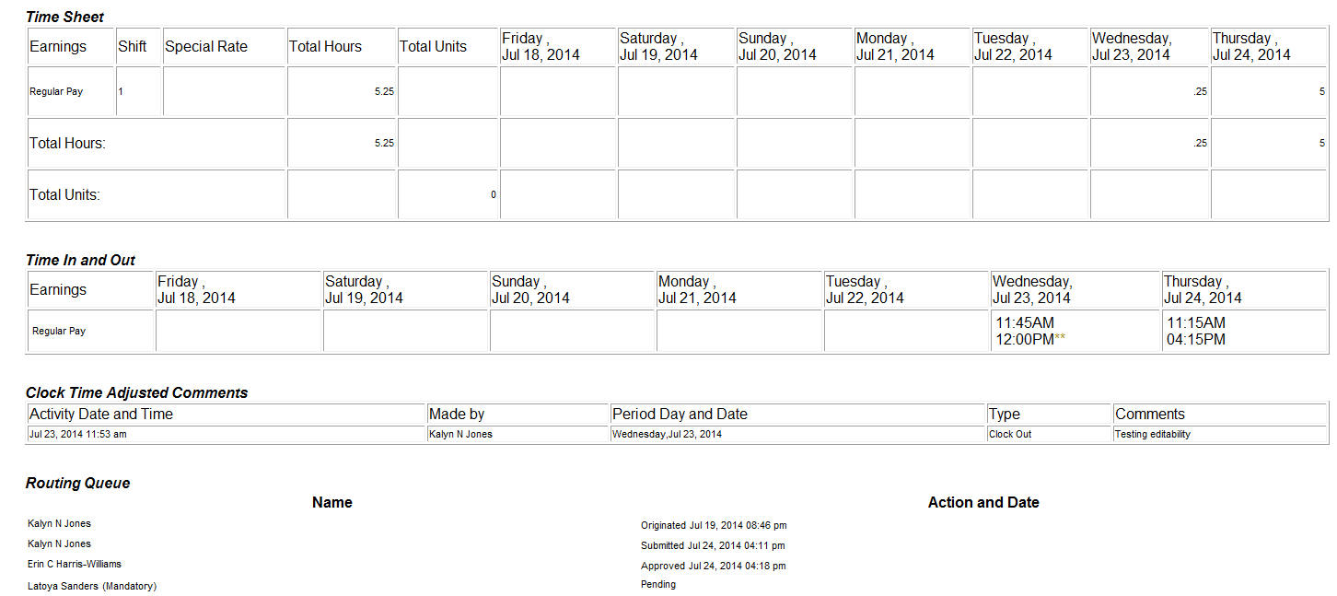

**Supervisor’s Name**

Employee’s Name  
Employee’s Name  
Supervisor’s Name  
Acknowledger’s Name

|  |  |
| --- | --- |
| **Step 17. Routing Queue** | To verify approval status of a timecard, view the Routing Queue area of the timecard |
|  | Press **‘Exit’** and **‘Site Map’** to return to the Banner Web Homepage |

**WTE Definitions**

|  |  |
| --- | --- |
| **Term** | **Definition** |
| **Clock In and Out** | Time entry feature used to punch in and out, mimicking the functionality of a time clock. |
| **Queue Status** | Status of the time transaction while in the approval queue. |
| **Transaction Status** | Tells the Approver the status of the timecard. |
| **Pay Period** | Biweekly pay periods cover a designated two week period beginning on Sunday and ending two weeks later on Saturday. (June 19, 2016 to July 2, 2016) |
| **Approver** | An individual with the ability to update, change, return, or approve time submitted by the employee. |
| **Originator** | The employee clocking in and out of a timecard during pay periods. |
| **Acknowledger** | A Human Resources professional that is responsible for reviewing timecard information before the time is allowed for Payroll. |

**WTE Status Displays**

|  |  |
| --- | --- |
| **Status** | **Definition** |
| **Not Started** | Employee’s timecard has not been initialized at all. |
| **In Progress** | Employee has initialized the timecard. Hours may or may not be saved in this status. This status is the status of an Active timecard. |
| **Pending** | Employee’s timecard has been submitted for Approval. The timecard will remain in this status until Approval by Department and Acknowledgment by Human Resources has been completed. |
| **Approved** | Timecard has been approved by the Department. |
| **Completed** | Timecard has been acknowledged by Human Resources and fully processed through Payroll. |

**WTE Buttons/Icons**

|  |  |
| --- | --- |
| **Button Description** | **Button Function** |
| **Timecard** | Displays the timecard appropriate for the selected job and pay period. |
| **Save** | Commits data entered in timecard. |
| **Comments** | Employee can enter freeform comments that will be displayed on the timecard page if not marked confidential by the Originator. Place in the timecard where an employee leaves messages regarding issues with a timecard that need to be addressed by an Approver. |
| **Preview** | Displays the preview page that shows employee’s detailed clock ins and outs, total hours earned, and any non-confidential messages left on the timecard page. |
| **Submit for Approval** | Allows the employee to submit time to Approve for Approval. A certification page activates before the timecard is successfully submitted, requiring the employee to certify the information as true and accurate using the same Banner Web PIN number used to access the timecard as an added layer of accountability for timecard entries. |
| **Approve** | Allows the approver to approve a timecard that has already been submitted by the employer. This action is taken during the designated approval deadline to send an accurate timecard for a pay period to payroll status. |
| **Next** | Displays information for the following week in the pay period. |
| **Previous** | Displays information for the preceding week in the pay period. |
| **Return Time** | Allows the employee to recall the timecard before the next person in the approval queue takes action. The timecard status will change from ‘Pending’ back to ‘In Progress’. This feature is helpful if an employee prematurely ‘Submit for Approval’ the timecard. |
| **Previous Menu** | Displays the Timecard page. A summary of hours and shifts is broken down on this page. |
| **Change Selection** | Toggles between timesheet page and selection page |
| **Add New Line** | Redisplays the page for the current day with a new line added to the end. |
| **Delete** | Deletes the entire days’ time entries. A confirmation page pops up before a deletion is allowed to ensure that this is an action that an Approver wishes to take. To remove a time without deleting the entire days’ time entries, use the delete feature from the keyboard and not the delete button feature from the timecard to make a change. |

**Supervisor FAQs**

**1. Q: How do I correct a timecard in WTE that was assigned to the wrong organization code?**

**A:** A timecard in WTE is driven by the data (including the organization code) entered in ePAF for the employee’s current personnel action. Each personnel action is assigned its own timecard in WTE. Please make sure that your timecard description matches the position that you are available to clock in/out at each session. If you feel that there is a discrepancy please contact HR to resolve immediately.

**2. Q: How do I correct a timecard in WTE that was assigned to a different supervisor?**

**A:** Once a timecard is activated by the student in WTE during a specific pay period, the supervisor that was initially assigned to the timecard is the approver of the timecard until the student submits the timecard for approval. At which time the timecard will be pushed to the approval que for the new supervisor identified by the unit to HR. When possible, requests to update a supervisor must be coordinated with pay period dates as mid-stream changes cause unnecessary issues. If there are errors in a timecard the initial supervisor of the timecard will be responsible for updates, but once the timecard gets submitted it will be pushed to the approval que for the new supervisor.

**3. Q: How do I correct a timecard that has not been submitted on time by a student and is still in need of an adjustment?**

**A:** The supervisor must submit the incomplete timecard first and then take action to change record and then approve. However, this is a violation of student employment roles as a supervisor is only responsible for the approval of time entries and not submission, unless the submission is under extenuating circumstances.

**4. Q: How will I know if a student has an error in his/her timecard?**

**A:** You should regularly use the ‘preview’ button in WTE to check the status of your student(s) time entry during the entire biweekly pay period. As well, every Thursday at 12 noon a report entitled “Missed Punches Report” is sent automatically via email from [hrstudents@xula.edu](mailto:hrstudents@xula.edu) to inform you of dates and times of incomplete time records that need your attention.

**5. Q: What is my responsibility with the “Missed Punches Report”?**

**A:** As a supervisor it is your responsibility to correct incomplete time records prior to the student timecard submission deadline. The Missed Punches Report is formatted to provide you with the date and time of the incomplete time entry. If you fail to correct the timecard before the deadline the student will be unable to submit their timecard, which can result in non-payment for the pay period. This system was designed to make timekeeping, submissions, and approvals effortless. However, if you are spending ample time on frequent adjustments please council with your student on the behavior immediately.

**6. Q: How do I adjust a time record in WTE?**

**A:** Refer to Steps 10-15 of the Banner WTE Supervisor’s Guide. As well, you can select “change time record” or press the “change record” button in the student’s timecard to make adjustments.

**7. Q: Why do I constantly have to fix my student’s timecards?**

**A:** If you are constantly adjusting a student’s timecard, you should council with the student to address his/her behavior using the time-keeping system. If you do not achieve successful results, please refer the student to Human Resources Compensation Analyst for further action.

**8. Q: Today is my student’s first day of work and he/she cannot clock in. What do I do?**

**A:** There are only two reasons a student cannot clock in: 1) HR has failed to assign a supervisor to the timecard, making it inaccessible. 2) The student is not yet authorized by HR to work in your unit. Please contact or visit HR immediately to resolve. The student is ineligible to work in your unit until resolved by HR.

**9. Q: What happens if upon approval I press the wrong button and restart the student’s timecard instead of approving it?**

**A:** It is a good contingency plan to keep an internal record of time (paper timecard) in case time must be manually re-entered. However, it is a violation of student employment roles regarding excessive manual time entries.

**10. Q: What happens if my student clocks in/out, but tells me that the system did not record his/her time, which causes me to manually fix the timecard?**

**A:** Systematically there is only one known glitch that will prohibit clocking in/out by giving an error that states “Clock time has been adjusted and a comment is required”. To work around this glitch, simply have the student press the ‘Employee’ link at the top of the page, refresh the timecard, and press the clock icon and “Save” the time transaction. Please note that successful time entries are only captured when the comment reads, “Time entered has been accepted”.

**11. Q: Why can’t I see any of my students’ timecards?**

**A:** Until the first student of the pay period activates his/her timecard, there will be no records to view upon activation all students in your que will be visible and timecard status will be available.