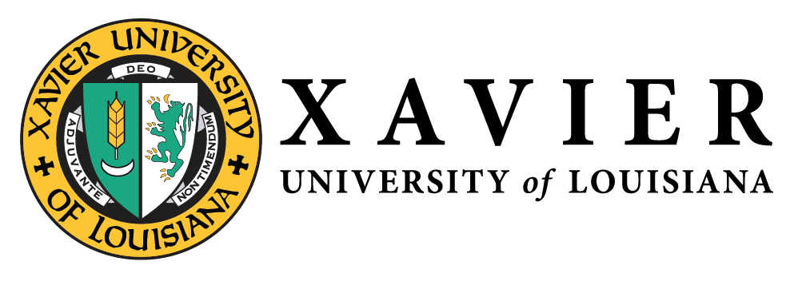
National Alumni Association
1 Drexel Drive, Box 66 • New Orleans, Louisiana 70125 • (504) 520-7575 • FAX (504) 520-7915

NATIONAL ALUMNI  OFFICERS 2019-2020  1 Drexel Drive  Campus Box 66  New Orleans, LA 70125  (504) 520-6782  1-877-WE LUV XU  Mr. Randall McHenry’86  President  randall@mchenryinc.net  Dr. Trevonne Thompson’97  1st Vice President  Trevonne.thompson@gmail.com  Ms. Chakita Holmes’03  2nd Vice President  chakitaholmes@yahoo.com  Nicole M. Golden’00  Corresponding Secretary  ndmarchand@gmail.com  Ms. Tiffany Devereaux’98  Recording Secretary  ttdex@yahoo.com  Mr. Kevin Barnes’11  Treasurer  kevinlbarnes@bellsouth.net  Gwen Charles’80  Parliamentarian  gwendolyn.charles@gmail.com | May 9, 2020  Report of the 1st Vice President &  The Resource and Development Committee  We are expecting to receive $2500 in proceeds from the apparel Pop-Up Shop for Homecoming 2019.  We raffled a Terrance Osborne print during Homecoming 2019 and made $400.  We are exploring new opportunities for additional resources for the remainder of 2020.  Trevonne M. Thompson, ‘97  1st Vice President

